**Project-based**

**product development**

**The Sustainability Barometer**

A solution to assess the sustainability of a business idea.

Wisam Orabi Alkhen

Mattias Lindblom

Lovisa Berglund

Clément Lefebvre

Ahmad Setoodeh

Project work report – Project based product development

Main field of study: Computer science and industrial design

Credits: 15 ECTS

Semester/year: Autumn/2022

Supervisor: Magnus Eriksson

Examiner: Magnus Eriksson

Course code/registration number: IG019A/DT053A/DT169G/ET008A/IG044G

# Abstract

This report is about the Project-based product development, done in coordination between Mid Sweden University and a company, in this case Bolagsverket. The core of the problem given was to find a solution to improve the sustainability of companies. The project was conducted by a group of 5 students from different backgrounds. To solve this problem, multiple reflection phases were conducted following the scrum agile method, and led to the sustainability barometer. It’s a website on which the entrepreneur can take a form containing questions about sustainability. Based on his answers, an artificial intelligence will assess the sustainability of his business idea and give educational material depending on the points to improve. The website is using a headless approach, meaning that every component is separated for better scalability. In order for the different parts to do their job, languages and frameworks such as VueJS, .NET, Python, Laravel were used. The result of this project is a fully functional website, with a tested and accessible user interface. A lot of thought was put on having it as user-friendly as possible. The work produced here will serve as a solid base for Bolagsverket to build on and add features.

**Keywords:** VueJS, Laravel, Python, php, .NET, MySQL database, Artificial intelligence, website, sustainability, barometer, The Swedish Companies Registration Office, scrum

**Nyckelord:** VueJS, Laravel, Python, php, .NET, MySQL, databas, Artificiell intelligens, Webbplats, hållbarhet, barometer, Bolagsverket, Scrum

# Acknowledgements

This project would not have been possible without the implication of the team at Bolagsverket. As so, a few words of appreciation are welcome.

First, we would like to extend our thanks to Erika Sjödin, our contact person at the company. She was very invested in the project and followed and guided us until the end.

We would also like to thank every person that gave us really useful insights and tips, among which Pontus Söderlund, Jonas Eriksson, Hellsten Joa, Thorgren Helene, Shaif Ayad. We wouldn’t have been able to deliver such a finished product without their help.

Finally, a big thank you to Magnus Eriksson, our tutor, for his support all throughout the project.

# Table of Contents

**Abstract** **1**

**Acknowledgements** **3**

**Table of Contents** **4**

**Terminology** **8**

**1. Introduction** **9**

1.1. Background and motivation 9

1.2. Overall aim and problem statement 11

1.3. Research questions 11

1.4. Scope 12

1.5. Outline 12

1.6. Division of work 13

**2. Theory** **15**

2.1. Design principles 15

2.2. Scrum 16

2.3. Design thinking 18

2.4. NABC 19

2.5. SWOT- analysis 19

2.6. Customer journey 20

2.7. Impact mapping 20

2.8. User stories 20

2.9. Kano model 21

2.10. Usability goals 22

2.11. General architecture 23

2.12. AI/ Machine learning explanation 24

2.12.1. Naive bayes 25

2.13. API 26

2.14. Languages used 27

2.15. Related work 28

2.15.1. Basic Business Assessment Tool 28

2.15.2. Sustainability assessment tool 28

2.15.3. Sustainability Assessment and Reporting of Companies 29

**3. Methodology** **30**

3.1. Project method description 30

3.2. Emphasize and define 31

3.2.1. NABC 31

3.2.2. SWOT analysis 31

3.2.3. Customer journey 32

3.2.4. Requirement management 32

3.2.4.1. Impact mapping 34

3.2.4.2. User story 34

3.2.4.3. Kano model for prioritization 34

3.2.4.4. Product backlog 35

3.3. Ideate 35

3.3.1. Design studio 35

3.4. Prototype 36

3.5. Sustainability questions 37

3.6. Tests 37

3.6.1. Form for testing questions 37

3.6.2. Website security 38

3.6.3. Validation 38

3.6.4. Performance tests 39

3.6.5. User tests 40

3.7. Project evaluation method 42

**4. Approach** **42**

4.1. Alternative approaches for hardware 43

4.1.1. Cloud - Google Cloud Platform 43

4.1.2. Cloud - Amazon Web Services 43

4.1.3. Local server 44

4.2. Alternative approaches for software 44

4.2.1. Website- standalone 44

4.2.2. Website- headless 45

4.2.3. Application 45

4.3. Comparison of approaches 45

4.4. Chosen approach 48

**5. Implementation** **49**

5.1. Front end implementation 49

5.2. Database implementation 57

5.3. AI implementation 58

5.4. API implementation 59

5.5. Back end implementation 60

**6. Results** **73**

6.1. Emphasize and define 73

6.1.1. NABC- pitch 73

6.1.2. SWOT- analysis 74

6.1.3. Use case 76

6.1.4. Customer journey result 77

6.1.5. Impact mapping 77

6.1.6. Product backlog 79

6.2. Ideate 83

6.3. Resulting product 84

6.4. Tests results 88

6.4.1. Performance test 88

6.4.2. User tests 89

6.4.3. Cross validation 89

**7. Discussion** **90**

7.1. Analysis and discussion of results 90

7.1.1. User tests discussion 90

7.2. Project method discussion 91

7.3. Consequence analysis 91

7.4. Ethical and societal discussion 91

**8. Conclusions** **93**

8.1. Future Work 93

8.1.1. Integration to other websites 93

8.1.2. Optimization of the results 93

8.1.3. Engaging users to take the test 94

8.1.4. Creating a global knowledge of sustainability 94

**References** **95**

**Appendix A: Source Code and website URL** **96**

**Appendix B: questions for sustainability** **97**

# 

# Terminology

**Acronyms**

Minimum Viable Product (MVP)

Application Programming Interface (API)

Cascading Style Sheets (CSS)

JavaScript (JS)

HyperText Markup Language (HTML)

Test-Driven Development (TDD)

Artificial intelligence (AI)

# Introduction

This report is a result of the product development work that has been conducted in connection with the course *Project-based product development* 15 ECTS, at Mid Sweden University in fall 2022. The course gives students the opportunity to work closely with a company or authority, to solve a problem that has been expressed. This project has been proposed and carried out in collaboration with The Swedish Companies Registration Office, which in this report is referred to as Bolagsverket.

In chapter 1.1 *Background and motivation*, an introduction to the problem area that the project regards, is given. Chapter 1.2 *Overall aim and problem statement*, describes what problem has been investigated and the purpose of the project. Chapter 1.3 *Scope* explains what the work has been focused on and also limitations. 1.5 *Outline* describes the outline of the report and what the different chapters are about. Finally chapter 1.6 *Division of work*, explains how overall tasks have been divided between the members of the group.

## Background and motivation

It is now more visible than ever that there is a need to protect the environment. This is to ensure that future generations will be able to meet their needs in the same way that today’s society is able to meet current needs. For individuals in everyday life, various actions can be made in order to work with sustainability. There are more and more opportunities being offered to make sustainable choices. Unfortunately for entrepreneurs that are about to start new businesses, this might not be as easy to find the same opportunities. Bolagsverket has a responsibility as an authority to contribute in some way to a positive impact on the climate and to create better conditions for a sustainable future. By helping new entrepreneurs to think about sustainability even before their companies are created, a large positive impact on the climate can be made in the longer run. In this way companies will start off developing their businesses in a sustainable way from the beginning rather than spending time researching and changing their ways of working in order to promote sustainability.[1]

Sustainability takes a large part in new ideas and thoughts about the future. The expression “sustainable business” in this report is mainly used to define the work companies do which has a positive impact on the economy, the environment or the society. The *2030 agenda for Sustainable Development* was adopted by all United Nations member states in 2015. It provides a shared blueprint for peace and prosperity for people and the planet, both now and into the future. The root of the agenda is the 17 Sustainable Development Goals (SDGs) which are expected to be reached by the year 2030. The goals are a call for action by all countries in the partnership. The goals recognize that ending deprivations such as poverty must be done at the same time as health and education is improved, inequality is reduced, economic growth is spur, all in the same time as climate changes are tackled and oceans and forests are preserved. [2]

The purpose of sustainability projects in companies is usually to create a connection between business work and sustainability work together in an agile way. This to develop, save costs and optimize entrepreneurs' business at the same time as achieving better sustainability. [3] In order for future companies to develop their upcoming business in a sustainable way, the team believes that there is a need to integrate the 17 Sustainable Development Goals to the entrepreneurs' business idea scenarios and systems. By doing this it is expected to benefit the entrepreneurs business to achieve a better and more sustainable future for all.

## Overall aim and problem statement

As a governmental organization, Bolagsverket is determined to the values that it represents. They want to help every business idea come to life, and to support existing businesses in their growth. But as previously mentioned, since a few years ago, exponential growth is often linked to unsustainable business practices. To prevent this development, the aim for this project was to create an artificial intelligence-driven website where entrepreneurs are able to assess the sustainability of their business ideas. The idea with this service was also to help entrepreneurs to determine which areas they can improve and be provided with targeted information and tips on what to do in order to develop their business in a more sustainable way.

The service which is referred to as the Sustainability Barometer, aims to integrate sustainability into the business from the very start. As a result, businesses could benefit from working more sustainably since it will most likely provide an advantage from a competitive point of view. But in the bigger picture the main purpose is that it could lead to an improvement in the quality of life of everyone in the world. This by taking the UN:s 17 sustainable goals into account when developing the sustainability barometer.

## Research questions

The problem raised by Bolagsverket and what the team have been working on during this project was :

* How to help new entrepreneurs to develop their upcoming business in a sustainable way?

## Scope

For this project, the team chose to focus on the minimum viable product (MVP). Since the time frame was very limited, the goal was not to produce a software ready for production, that’s why more focus was put on creating a software meeting the minimum requirements.

The team also thought about who the solution should be made for. Since it aims to be integrated into a website related to Bolagsverket, the team thought about designing it for all businesses. The targeted group was later reduced to only entrepreneurs that want to start their business, since it would be much more impactful for them to think about sustainability even before creating their business.

As a result of all these decisions, the team decided to focus on Swedish as the language of the website, because it would mainly be used by Swedish entrepreneurs. As the solution is aimed to be flexible, the language can be changed quite easily, opening the solution to more people. Because this course is in English and because there is a non-swedish student in the group, the prototype will still be presented in english.

## Outline

This document is divided into 8 main parts, called chapters.

* This introduction is the first chapter and is used to introduce the project.
* The second chapter is about the theory, which explains the principles of the methods and tools used.
* The third chapter is the methodology, so how did these methods and tools were used for this specific project.
* The fourth chapter is describing the approach used to tackle the problem that was given.
* The fifth chapter is about the implementation, in other words, it explains in very practical terms how the product was developed.
* The sixth chapter goes through the results, tests and all the work produced.
* The seventh chapter discusses the approach, tools, and decisions used during this project. It adds perspective to the work produced.
* Finally, the eighth chapter is a conclusion for the whole report, introducing ideas for the future of the project.

## Division of work

The work was divided equally between all group members, based on our skills and experience. Some roles such as scrum master or product owner were switched every sprint so everyone could experience them.

Every project needs to have management overview and supervision, so Lovisa, which is less focused on technical development because of her field of work, handled this.

Wissam, having previous experience with artificial intelligence, chose to focus on this part of the project.

Ahmad worked on the backend and database because of his previous experiences working with these technologies.

Mattias took upon the role of front end development together with Clément. There were a lot of new developing techniques to be learned and Mattias was interested in the new front end frameworks that were going to be used during the project. There was also close communication with Ahmad about the backend, and Lovisa about the questions since all parts are connected to display information correctly on the front end. In this role Mattias got to put most of his previous knowledge about web design, writing program code and designing databases to use.

On top of helping Mattias with the front end, Clément focused on the API because he wanted to know more about this technology that was new to everyone. He also wanted to improve his skills on the Google Cloud Platform, that’s why he was in charge of hosting the solution to the cloud.

To get an overview of the participation of every member in the development part of the project, here are some insights pulled from the github page of the project. See image 1 and image 2.

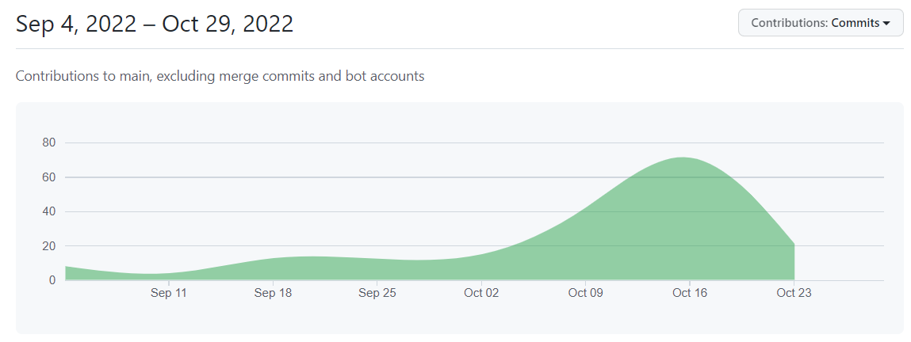

*Image 1. Amount of commits to git repository during project*

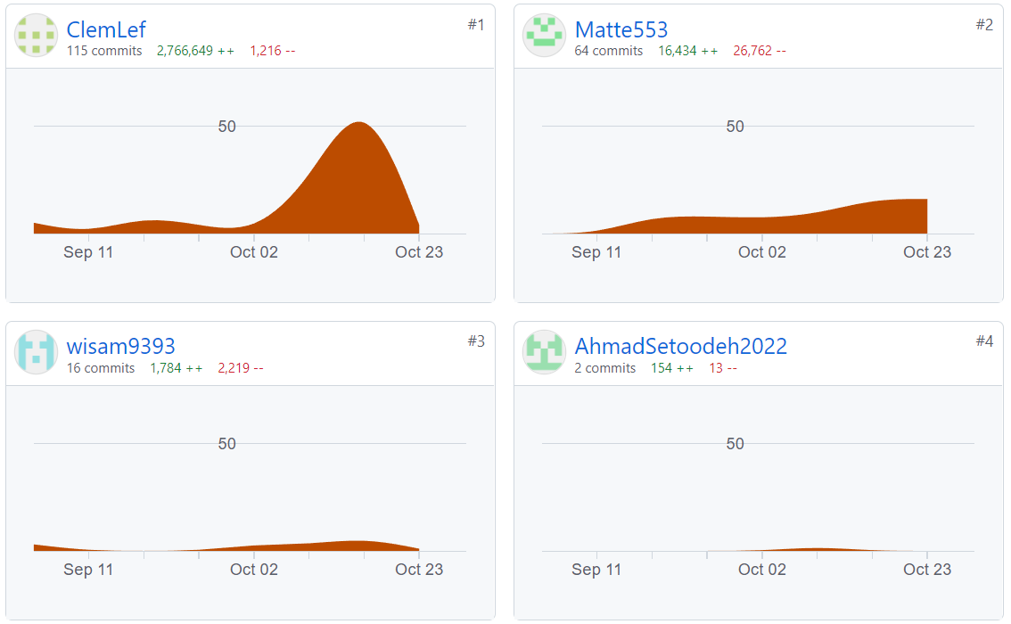

*Image 2. Amount of commits to git according to each member*

This data does not represent the real work produced by each member. For example, working on the front end required more commits to refresh the hosted website. That’s a reason why Clément has so many commits, most of them are minor commits. Also, because Wissam and Ahmad worked on developing programs independently to the main website, they worked mainly on their local computer, without having to commit every time.

# Theory

To get a better understanding of the project’s methods and tools, some descriptions are needed. This theory chapter will go through each method and tool used, describing in a detailed way, using references.

## Design principles

Design principles are there to help designers think about different aspects of the design when a user interface is developed. The design principles should make an interface more useful and easy to understand. According to Rogers, Sharp and Preece [1 pp. 26-31] there are five principles to follow. These principals are listed below. [4]

Visibility: Visibility is about making functions as clear as possible, because if functions are clearer, the user will have an easier time understanding what to do late.

Feedback: If a function provides clear feedback, the user understands what has happened, that something has happened and if it went well. Feedback must be clear and guiding regarding what the user should do next.

Constraints: Constraints are that the interface should show the user what it does not can do. As an example in a text document the option to print is always visible, even if a printer is not available. It should help users understand that they cannot print, so the user does not search further for a "print" button.

Consistency: Whether the interface is consistent with its use of icons and similar elements, it will be easier to understand how it works in the different views which exist, it is called internal consistency. It guides the user if the interface has rules and follows them. It could be external consistency as the interface has similar icons and other elements that other apps have, things that the user is used to.

Affordance: The interface should be designed to show how it should be used. If a door only has a plate as a handle, it shows that you should push to open the door, the same way interfaces should be designed. They must be designed so that it guides the user to how to do with them the various elements in the interface. [4]

## Scrum

Scrum can be described as a framework that helps organizations, teams and people to generate value through adaptive solutions for complex problems. The scrum method is based on timeboxing, which means that time is the one factor in the project work that is not being compromised. Therefore work in scrum is divided into different sprints where a goal is defined and the group works to achieve this common sprint goal. When working according to the scrum method the first thing that is done is developing a product backlog. The product backlog is a prioritized list of requirements that the product should contain based on the product goal. This can be compared to a to-do list with tasks to complete during the project to meet the requirements. When the product backlog is fully developed the first sprint starts with developing a sprint backlog by selecting requirements from the product backlog. The selected requirements thus form the basis for the tasks which will be completed during the current sprint. The scrum method also contains daily scrum meetings where the progress towards the sprint goal is inspected. At the end of each sprint the results of the sprint work is presented in so-called sprint reviews. A retrospective meeting is also held to reflect about the finished sprint. After this, the previous steps are repeated in a new sprint with a new sprint goal. The scrum method is illustrated in image 3. [5]

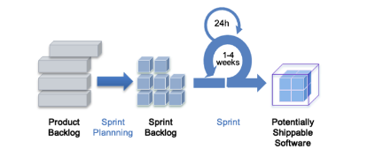

*Image 3. The Scrum method illustrated.* [5]

## Design thinking

Design thinking is an agile methodology that encourages questioning, experimenting, observing, and innovating while it acknowledges that there isn’t only one way to solve a problem [6]. When working according to the methodology, the project is divided into different phases. The amount of phases the work is being divided into differs for each project. In this project, the work will be divided into five stages. These stages are empathize, define, ideate, prototype and test. It is important to clarify that these steps are not to be seen as a linear process. The Design Thinking steps are iterative and can be repeated throughout the project. The *empathize* phase is about researching the user's needs. The *define* phase is about stating the users needs and problems. The *ideate* phase is about challenging assumptions and creating ideas. The *prototype* phase is about creating solutions. The *test* phase is about trying out the solution. The design thinking methods are illustrated in image 4. [7]

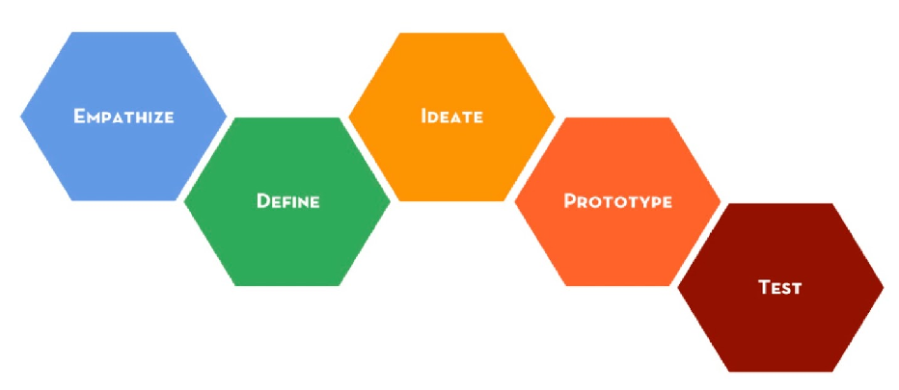

*Image 4. The Design Thinking methodology.*[8]

## NABC

The NABC model is a tool that can help define a business idea and state what makes the idea valuable to potential customers . The model can also be used for preparing a presentation or a pich. The N in NABC stands for need, A stands for approach, B stands for benefit and C stands for competition. The idea is to divide the business idea into these areas. In the “need” part of the model it is stated what key need the idea will meet and who’s need this is. In the “approach” part it is stated what approach will be used in order to meet this need. It is about the solution. The “benefit” part states what benefit the user or the customer can get from using the service or business solution. Lastly the “competition” part of the model states other solutions to the same problem that in the future can be potential competitors. [9]

## SWOT- analysis

SWOT stands for strengths, weaknesses, opportunities and threats. It is a framework that can be used for positioning a specific business or idea on the market relatively towards other businesses or ideas. The categories strengths and weaknesses are internal factors that the business or the team somewhat can affect. Strengths can be about which areas a company excels. For example it can be a unique service, an innovative marketing strategy or a loyal customer base. Weaknesses can be about things that prevent the company or team from achieving its full potential. For example it can be that expertise skills are lacking or the use of old technology. The categories opportunities and threats are external factors that the team has no control over and can't change. It is something that belongs to the market. Opportunities can for example be trends on the market. Weaknesses can be things like laws and regulations that will affect your business negatively. For example it can also be about disruptions in the distribution chain or changed customer behaviors. [10]

## 

## Customer journey

A customer journey describes a user's interaction with a product, service, system or an organization. It is a method for clarifying and identifying the experience in all the steps a person performs when using it. The customer journey covers activities before, during and after the process. It can be used for understanding users and experiences but also for testing various concepts that are being developed. The customer journey illuminates all interactions, also called touch points, the user has with the product, service, system or organization. This aims to analyze what the user feels during the process and thereby capture potential opportunities in order to improve the customer journey. [11]

## Impact mapping

Impact mapping is a graphical planning method for deciding which features are to be built into a product. By using this method it will ensure that all the identified features will have an impact on achieving the project goal. This is because the method begins with the intended goal and extends to mapping the specific features. The impact map illustrates the path from the project goal to the relevant stakeholders, how they can achieve the intended goal and what functionality is needed for them to perform these desirable actions. [12] The impact map should be able to answer the questions: who? how? and what? From the completed impact map user stories can then be created in order to further state requirements.

## User stories

User stories are a simple way to state requirements. A user story is a short description of what a user wants to achieve. A common template for formulating user stories is to structure them as follows: As a [stakeholder] I want to have [goal], so I can [benefit]. By using this method, managing requirements can be done without having to create formal specifications while having to do administrative work . User stories are also a common method for developers to describe non-functional requirements such as security, performance, etc. [13]

## Kano model

With the help of the Kano model, requirements and performance goals can be divided into categories depending on the degree to which they are likely to satisfy customers. The use for this model is to help prioritize what feature might be the most beneficial for the customer. [14] When having a list of requirements, the Kano- model can be used to weigh these features according to the two competing criteria, their potential to satisfy customers and the investment needed to implement them. [15]

The Kano model is illustrated in image 5. In the image, the orange arrow represents requirements that are expected and must be implemented into the solution. According to the kano model, fulfilling these requirements does not increase customer satisfaction. On the other hand, if these are not fulfilled, it will affect the customer satisfaction in a negative way. The blue arrow in the image represents requirements that will help the solution deliver a more satisfying result for the customer. These goals could be specifications that would help the performance or usability of the solution. The customer satisfaction increases linearly according to the level of implementation. The green arrow represents the requirements for the solution that will result in a positive impact on the customer. These requirements greatly improve the quality of the solution. Since they are unspoken requirements that the customer doesn't know that they want, not fulfilling these will not have a negative impact on the customer satisfaction. [16]

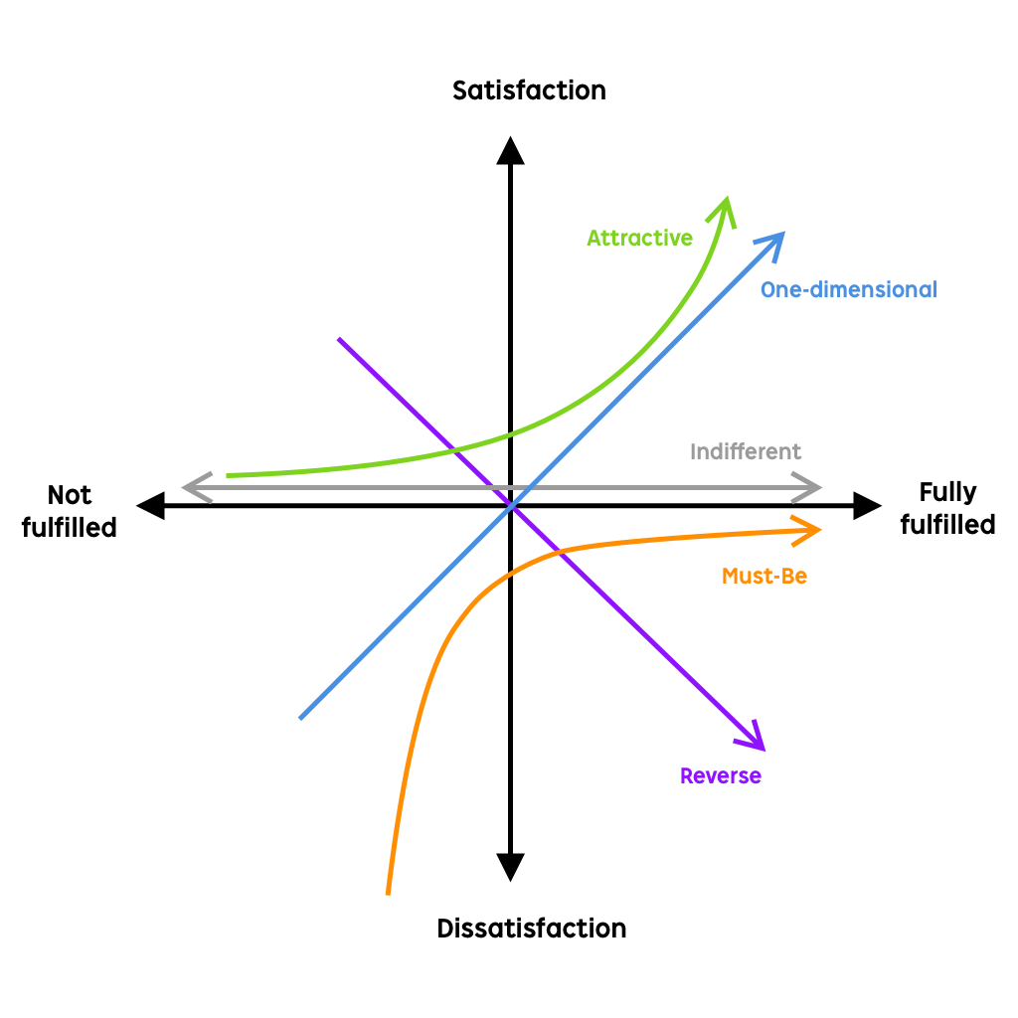

*Image 5. Uxplanet. (2019). Kano Model Analysis in Product Design. Retrieved: 2022-09-12.*[*https://uxplanet.org/kano-model-analysis-in-product-design-7a3cca3e51ed*](https://uxplanet.org/kano-model-analysis-in-product-design-7a3cca3e51ed)

## Usability goals

Usability goals should ensure that the interface is easy to learn, simple and efficient to use. Rogers, Sharp and Preece [1 pp. 19-22] state that there are six different goals to follow in order to get a good interface. [4]

Effectiveness: If an interface is effective, it means that the interface can do everything it is supposed to do.

Efficiency: Can the user be more efficient and productive if the user is used to and knows the interface? An interface can have keyboard shortcuts, or one that saves previously completed tasks are examples of interfaces that become more efficient when the user is used to it and knows how.

Safety: Safety means that the user should not accidentally do something they do not want. If an action has permanent consequences, it should be clear and it is beneficial if the interface double-checks with the user that it is sure it wants to carry out the action

Utility: Does the interface have the functions needed? Giving the user freedom and the ability to do what they want in the interface provides good usability.

Learnability: Can the user learn everything by exploring the interface? A good usability interface is one that doesn't need a manual, but allows users to explore and learn as they discover the various features.

Memorability: An interface that has good memorability is easy to remember how it works, or quickly figure out how to do it. [4]

## General architecture

Since a few years, developers and companies have two ways of developing a website, with either a monolithic or microservices approach [17].

* A monolithic system is a way to pack every component needed into a single process. As such, it doesn’t need any external access to other kinds of servers see image 6.
* Microservices is a way to organize resources into multiple processes, generally hosted on different servers. That way the different parts of the system can communicate with each other see image 6.

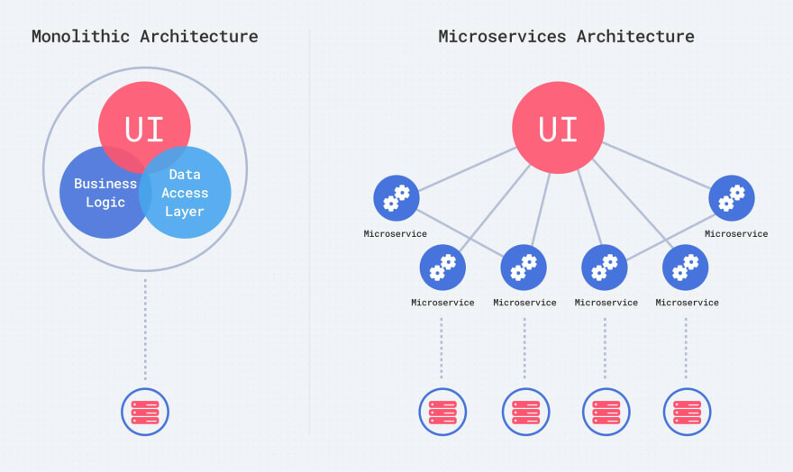

*Image 6 : simple representation of monolithic and microservices*

Each solution has their advantages and disadvantages, let’s take a closer look at the main advantages of each solution.

* Microservices :
  + easily scalable : in case the website is getting popular, allocating resources to each service based on demand is really easy.
  + easy development : because each resource is managed independently, developing and deploying updates without impacting other parts of the system is simple.
  + security : by carefully exposing only the information needed, microservices solutions tends to be more secure
* Monolithic :
  + easy deployment : because the architecture is so simple, the deployment of this kind of systems is much easier
  + shared information : because everything is bundled together, sharing information between processes is simple and does not rely on the network.

## AI/ Machine learning explanation

الترجمة طويلة جدًا ولا يمكن حفظها.

Artificial intelligence (AI) has no clear definition or generally accepted delineation. Artificial intelligence is defined as the ability of a machine to imitate intelligent human behavior. Artificial intelligence is also the name of the field of science and technology that aims to study, understand and develop computers and software with intelligent behavior. [18]

Applications of AI have already been of great importance for the development of internet platforms, information search, image recognition and automatic translation, but the practical impact of AI has been limited in large parts of business and public activities. In the last decade, however, access to data in electronic form and computer power have increased very quickly, which has significantly improved the conditions for AI applications in various businesses.

In order to be able to evaluate the AI potential for value creation and to exploit this potential, it is important to understand which possible areas of application exist in various industries, because it is in these that the value creation potential lies.

There are also possible applications that provide driving forces for AI development in companies and public activities. [18]

### Naive bayes

Naive Bayes’ theorem is one of the most popular machine learning methods, Machine Learning and Data Analytics, and Classification specifically, It is a probability-based machine learning method invented by Thomas Bayes. Naive Bayes is characterized by speed in processing and efficiency in forecasting operations. [19]

This method is based on the statistical concept of Bayes' theorem, which calculates the probability of a certain result occurring by verifying what is available and known, because it adopts the principle of independence assumptions so that it considers the relationship between all attributes, features as independent from each other.

Bayes classification model is characterized by ease of construction and development and the ability to process large data and outperform a number of advanced and complex algorithms. So that the model is trained with the data and its properties available in the databases, and then the model determines the type of new records and classifies them based on the data and statistics previously available to it.[19]

There are several algorithms that can be used in AI to determine the prediction, but the Naive Bayes algorithm has a high value in accuracy. The module trains through advance results from different areas and this step is called (train the module). When the module gets new values, those values are called (test set). Then, the module determines which class the test values belong to.[19]

## API

An API, short for Application Programming Interface, is a set of functions designed to fetch, retrieve, and send data between two computer programs or services [20]. The main goal of using an API is to hide the different parts of a program, only allowing access to necessary information. In that way, it is particularly good for database connections, because it allows programs to fetch data without having privileged access to the whole database.

An API is often used to create a headless architecture or headless design. A website implementing headless design means that the front end and back end are separated. Thanks to this design, the front end can be implemented in various ways and on various platforms, only using one backend see image 7.

*Image 7 : Functional diagram of a headless website*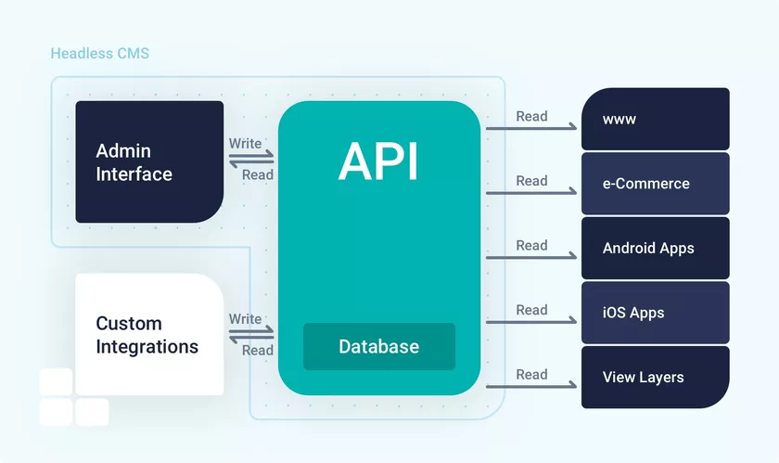

The HTTP GET method is the most simple : it is used to retrieve data from a database in this case. It can be data with a specified parameter (the id for example) or every data in a table.

The HTTP POST method is a little bit more complicated as it’s sending data to update the database. A response is then sent, either to return the status of the request (fail, pass…) or send back data.

These requests are very simple to use and versatile.

## Languages used

The main languages used for website development are HTML, CSS, JavaScript. There are frameworks that were made to simplify the use of these languages, such as the VueJS framework.

The VueJS framework is a modular platform that makes it easy to implement front ends in a website [21]. Its popularity among other front end frameworks is due to its flexibility, its ease of development and open source specification. This framework uses specific .vue files that mix HTML, CSS, and JS. This is also a great tool to create standalone front ends.

For the API, a lot of frameworks exist and their functions are basically all the same. Laravel is popular for building APIs because of its security, stability and ease of development and open source specification. Laravel is a PHP framework designed to create web apps. In this project, it was only used for its API. It was advised to use Laravel in combination with VueJS by a lot of internet resources.

.Net (C# windows platform) is an application development framework and in comparison with other frameworks it offers more scalability and flexibility and from users perspective offers a smooth experience.

MYSQL is a free and open source program that can be used both locally and on server.

## Related work

There are other sustainability barometers to evaluate a business. Most of them are not interactive, but written as a scientific article, book or a template for businesses to evaluate their own sustainability. A few sustainability barometers that have been analyzed seemed to use a form as a way of assessing sustainability either through a website or excel sheet. The approach is the same to evaluate an user's answers by letting the user answer questions through a form. A repeating approach pattern is to let the user assess their own sustainability. Our Sustainability barometer differs in that our service is utilizing modern AI technology to both assess the answers from the user and providing links and articles about how to improve in specific areas regarding sustainability.

### Basic Business Assessment Tool

The Basic Business Assessment Tool (BSAT) is a self assessment tool for small to medium businesses. There is an excel version and one online version of this tool created from a spreadsheet converter. [22]

### Sustainability assessment tool

Sustainability assessment tool (SAT) is a template to follow for companies to test their sustainability. This tool is presented as a PDF file. Inside the template, questions are asked regarding sustainability in the areas Economical, Social and Environmental. The result of The Sustainability assessment tool is created through manually letting the user evaluate its own answer to the questions. [23]

### Sustainability Assessment and Reporting of Companies

Sustainability Assessment and Reporting of Companies is a book about educating the reader about the connection between sustainability issues and companies strategies, activities and services [24]

# Methodology

In this chapter, the methods that have been used are presented and motivated. For this project the overall method was a combination between Scrum and Design Thinking. This chapter is structured based on the Design Thinking phases where the activities performed for each phase in the sprints are explained. In chapter *3.2 Project method description,* the overall method is explained. In subchapter *3.2.x Emphasize and define,* the activities that were carried out in order to get a deeper understanding of the real need behind the problem, are described. Requirement collection and prioritizing are also covered in this chapter. In subchapter *3.2.x Ideate,* activities that were carried out in order to create new ideas for reaching the needs are explained. In sub chapter *3.2.x Prototype*, the methods for developing the solution are explained. Sub chapter *3.2.x Test,* explains the methods for trying out the solutions.

## Project method description

As mentioned above, product development work was structured and conducted using a combination between two agile methods, Scrum and Design Thinking. The Design Thinking method worked as a suitable complement to Scrum. This is because the phases from Design Thinking were used to divide and structure work within the sprints. The workflow for the project is illustrated in image 8.

The reason why the work was chosen to be carried out in this way is because it was expected to generate an improvement for each sprint which in turn was expected to contribute to an iterative result. By going through the phases iteratively, new knowledge was added for each sprint and thereby improved the result. Since each sprint contained a variety of phases, it also ensured that all the different skills from the group were used.

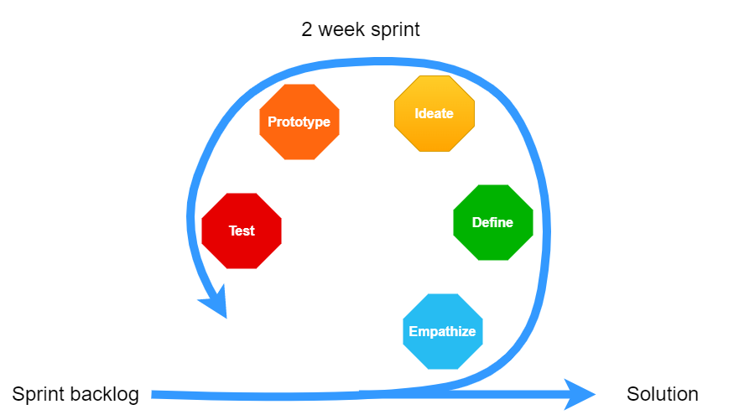

*Image 8. Design Thinking combined with Scrum*

## Emphasize and define

In order to get a deeper understanding of the real need behind the problem, the activities described in this subchapter were made.

### NABC

During the first week of the project the NABC- method was used in order to pitch the idea for the innovation coaches at Mid Sweden University. This gave both the innovation coaches and the team an overall picture of the idea and how the project was going to proceed. This helped the team to prepare for what needed to be done and why. It also created an opportunity for feedback from the innovation coaches regarding strategies in order to reach the project goal. With the method the product idea, how the final product was planned to be used and why it creates value was described. The method was used because it worked as a good guideline to grasp the problem while basic needs of the service were identified. The pitch was presented orally in front of the innovation coaches in 1,5 minutes. For this reason the pitch was directed as a speech to the innovation coaches.

### SWOT analysis

A SWOT- analysis was made in order to position the team project on the market and thereby analyze the team’s capability to reach the project goal. The internal categories strengths and weaknesses were studied from a preventively point of view. With the knowledge gathered from the internal analysis the team got an idea of activities and approaches that had to be changed in the project in order to reach the project goal in an effective way. This information helped to improve method choices particularly. The external factors, opportunities and threats were studied as a risk assessment. Even though the team could not affect these, the information from the analysis helped prepare the team for unwanted events. Overall the SWOT- analysis helped the team to develop the service based on preconditions and needs regarding both the team but also the intended users of the service .

### Customer journey

In order to discover how the process regarding the use of the service could be carried out in the most valuable way for the user, the customer journey method was used. For this the online whiteboard tool Miro was used. An already existing template for customer journeys was used. First the actions that would be a part of the user interaction with the service were decided by the team. Those aimed to describe what the customer does during the whole process. The actions stated an overall image of how the service was going to work. The actions were decided based on the requirement collection. Also the different touch points, the interactions the user have with the service while performing the actions were decided. These were decided by what the team found to be the most suitable with the wishes of the users in mind. The customers' thoughts and feelings during the touchpoints of the activities were then predicted. This part could mainly be done by assumptions since any user tests had not been made yet. For this customer journey the thoughts and feelings worked as a risk assessment for what the customer might have problems with. From this information opportunities could then be identified in order to prevent the risks of a negative interaction with the service.

### Requirement management

The following activities were carried out in order to capture, structure and prioritize requirements for the solution. Since the client had a very clear picture of what result they wanted from the solution, the majority of the requirements were collected from these expressed wishes during the time of the project. The client's expectations of the solution were expressed partly in the project description that was given to the team but also during the several meetings that were held. Apart from only the client's wishes of the solution, the group also spent time investigating what the intended users of the service found to be important and useful in a service like this. This was mainly done via the customer panel Bolagsverked uses for feedback and evaluation on the services they are developing. It was also done by asking already existing companies what features they think were needed. For collecting these user requirements a form was sent out. This was done at the same time as testing the sustainability questions that were created for the website. A form was sent out for this which also contained questions on their wishes for features. More detailed information about how these forms were created and used, can therefore be found in chapter *3.6.x Sustainability questions evaluation.*

The information that was generated from the above investigations, were then used in the following required management activities which is described in the subchapters below. Image 9 illustrates the activities that were used in order to produce the product backlog. As can be seen in image 9 the activities use case, impact mapping, user stories and kano model for prioritization were carried out. Even though the use case exercise is not included as a subchapter below, it was still part of the required management work in the procet. The reason why it’s not included is just because it also served benefits for other purposes of the project, not only the required management part and therefore is explained in chapter *3.3.3 Use case diagram.*

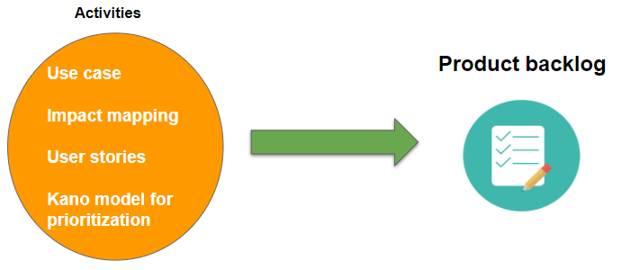

*Image 9. Activities for producing the product backlog*

### Impact mapping

Impact mapping was one of the first activities that were made early in the requirement capturing process. The stakeholders that were needed for the impact map were retrieved from the Use Case diagram that was created previously in the project. This was done with some modifications. From this information, the path could further be extended to show how the stakeholders could achieve the intended goal of the project and what functionality was needed for them to perform these actions regarding the service. This method was chosen because it clearly defines different deliverables that have to be developed in order to reach the goal of the project. When always having the project goal in mind, it will reduce the risk of developing something that does not add value to the project. From the completed impact map user stories were then created in order to further state the requirements.

### User story

In order to know who wants to do something and why, user stories were developed. The method was used for expressing what the stakeholders wanted to achieve with the solution. Based on the Impact Map that was created, the user stories were then formulated. The functionality needed for certain stakeholders to perform desirable actions, which were stated in the impact map, founded the base of the user stories. The user stories were formulated both for functional and nonfunctional requirements. The reason why this method was chosen was because managing requirements could be done without having to create very formal specifications. It was a quick but extensive way for formulating the requirements.

### Kano model for prioritization

When the user stories had been produced, they needed to be prioritized in order for the team to know what to focus on implementing first. With the help of the Kano model the prioritization was made. This resulted in a division of the user stories into three groups according to the graphs in the kano model (see chapter *4.6 Kano model*) . The three groups were named “must have”-, “should have”- and “nice to have”- requirements. The way of using the Kano model is similar to the requirement prioritization method MoSCow. The Kano system was used instead because of its educational way of illustrating how every requirement category will impact the satisfaction of the user. The requirements were also divided into functional and non functional requirements.

### Product backlog

The produced user stories were then compiled into a product backlog. For each user story it was also stated what actual requirement particular user stories related to. Since a product backlog must be a prioritized list of requirements , the results from the Kano- prioritization system were also stated for each user story.

Later this product backlog was then transferred into the agile project management tool Trello. This was done as a somewhat simplified version with only the actual user stories as the product backlog in Trello. For each sprint a number of user stories were chosen to focus on. This is what formed the sprint backlogs. The user stories in trello were broken down to activities that needed to be done in order to reach the requirement the user story was based on. With the use of the metod planning poker, sometimes called scrum poker, each activity was given a jointly generated number by the team which worked as a landmark for showing how important the activity was for the solution. Often the number was higher the more urgent it was assessed to get the activity done.

## Ideate

Since the client already had a clear vision of how they wanted the product to be implemented, the ideate phase of the project was not something that the majority of time was spent on. The idea generation mainly concerned how the design of the website would look like. Also more detailed decisions of how the group would decide to structure the solution, belonged to this phase. These decisions are explained in the next chapter for the sake of order.

## **Design studio**

To create the first mockups of the website, the exercise Design studio was used. Every member in the team got 10 minutes each to sketch ideas of how they thought the design would look like. Folded papers were used for sketching where every fold of the papers represented a different view of the website. The views sketched were home page, form page, result page and info page. After the 10 minutes had passed each member got time to show and explain each one of their views. When all team members had explained their sketches, the team used the best ideas and merged them together. By doing this, the design was democratically decided and everybody in the group got a saying.

## Prototype

For this project, instead of going with a monolithic architecture, it was decided to go with a microservices approach, as explained in 2.11 General Architecture. The main idea is to divide all the parts of the application to tiny services, each with a specific task. Because we are planning for the future of the website, and don’t know how many people will access it, a microservices approach was preferable. Also, since we divided the work between every group member, it was easier to work on the parts independently.

The technical part of the project can now be explained in detail. To better understand the explanation, it’s good to start with a representation of the project see image 10.

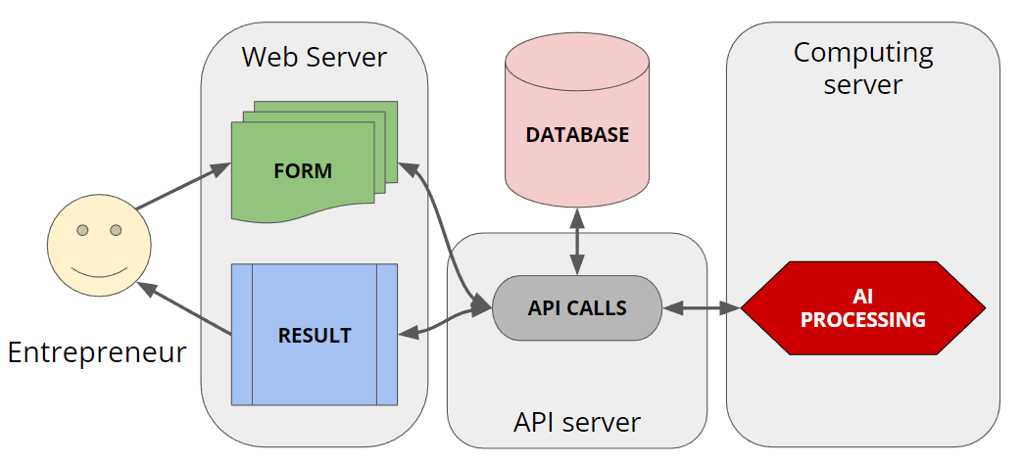

*Image 10. An overview of the projects components*

As you can see on this schema, there are 4 main components in the project, each separated from the other. Communication between the services are done with API calls.

Another thing to notice is that the database is inaccessible to every other service except from the API server. That way, each request has to go through the API server before being processed. It also simplifies the security, because now we can focus on securing only one element instead of securing every database throughout the project.

The computing server is written in Python, and implements a listening routine that checks form HTTP requests coming from the front end. As soon as a correctly formed request is received, the AI processing starts and when it’s done, sends back a response to the front end.

The web server is hosting the front end.

Finally, to challenge ourselves and to show that our solution can be fully functional, the group decided to host everything in Google Cloud. It’s a great way for our solution to be accessible from everywhere and so that everyone can try it.

## Sustainability questions

When deciding what questions to use for the sustainability form in the website, an already existing set of questions were decided to be used in order to save time. Bolagsverket had a previous project where students had come up with several relevant questions in order to measure sustainability. The questions were based on scientific research. Unfortunately these equations did only cover the environmental perspective of the sustainability problem, therefore the team had to come up with more sustainability questions.

## Tests

### Form for testing questions

Since some questions were made by the group, they lacked proper evaluation and testing. In order to test them, there was communication with Bolagsverket on how to proceed. Bolagsverket has a customer panel that consists of a mailing list of customers. There was communication with one of the managers for this customer panel and it was discussed to send the group's untested questions to the customer panel. A google form was made with the questions and input fields to receive feedback from the tester. But since Bolagsverket is an authority, any personal information could be regarded as sensitive, the questions had to be taken through the legal department for an approval before being sent to the customer panel.

The legal department could not give this approval to test the questions because of the limited time. This resulted in that all the questions were not evaluated by any companies.

### Website security

The most common types of web attacks are SQL injections, Cross-Site scripting and Denial of service [25].

Since the data processed does not contain any sensitive or personal information, this solution is not a major target for attacks. However, we still had to think about reinforcing the security.

First of all, since our website only contains one text field, the SQL injections are not a major threat. Anyway, the data can be accessed easily so there’s no point in attacking the website that way to gain information.

For Cross-Site scripting, as for SQL injections, there’s only one text field and we did everything to prevent this kind of attack.

Finally, about denial of service, there is nothing we can do about this on the project as it is because it depends on the way it will be hosted. On Google Cloud, some solutions exist to prevent this kind of attacks (load balancers for example) but in the end, the company will probably host this on their servers, which are probably already secure.

### Validation

To make sure the developed website was compliant with all website related standards, the w3c validator was used. This validator is well known in the website development sector. see image 11.

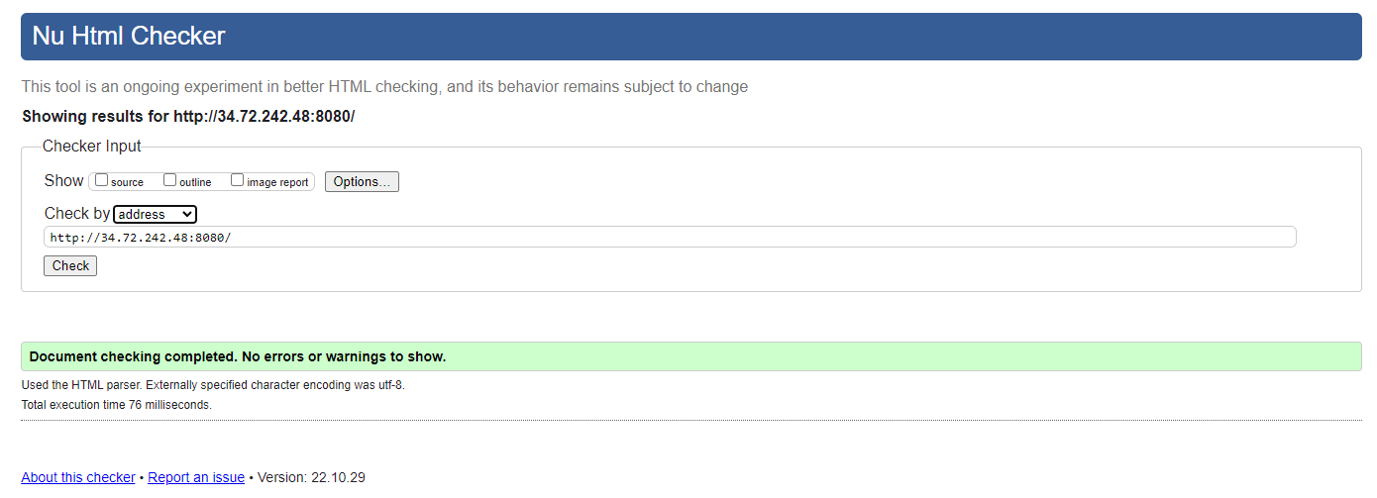

*Image 11 : The result of the website scan through W3C validator.*

As you can see on image 11, the website passed the w3c html checker without errors or warning. Moreover, the built-in VueJS lint was used to find and highlight any programming errors or bugs in the VueJS files. Finally, the warnings shown in the browser’s console were removed thanks to a code review that the team performed at the end of the project.

For the AI part, the python code was continuously checked for errors or warnings by a linter. Try catch exception method has been used to test a block of code for errors. The except block lets the developer handle the errors.

### Performance tests

To make sure the website was displayed properly and loaded relatively quickly, various tests were concluded. These tests followed a table containing various performance values, as displayed in the picture below. The results of the tests were taken into account when correcting the last bugs to improve performance. These results are displayed in section 6.4.1 of this report. see image 12 and 13.

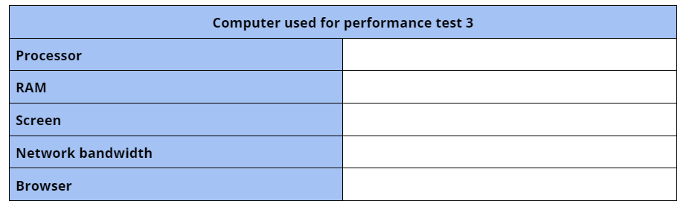

*Image 12 : table user to perform performance tests*

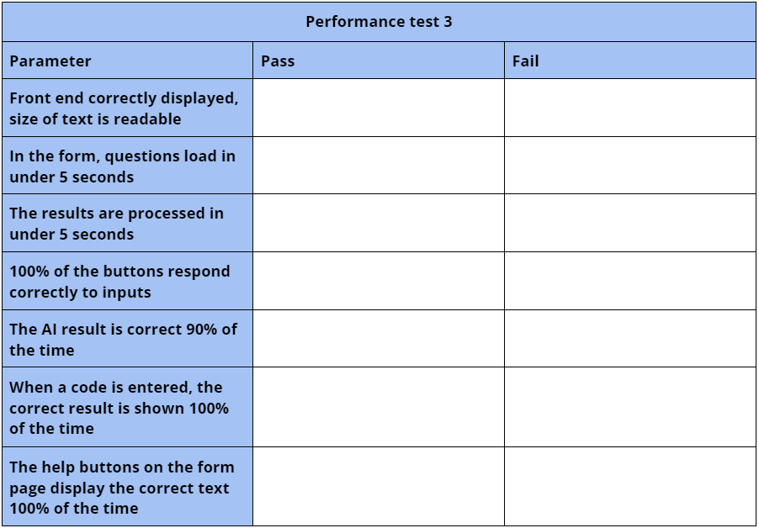

*Image 13 : table user to perform performance tests*

### User tests

The first usability tests were carried out with three randomly selected users from various groups. One subject was particularly fitting for the project as he is an entrepreneur, the target of the website. During the user tests, the following table was used. It contains the tasks the user had to do, an expected result, the actual result (quantifiable) and improvements. There were also three questions asked at the end to get feedback about the website in general. This table was not presented to the user during the test, he was only asked to do the task marked on this table and the test leader was responsible for timing actions and noting feedback see table 1.

**table 1 : user tests table**

| **User test 4** | | | |
| --- | --- | --- | --- |
| **Action** | **Expected result** | **Actual result** | **Improvements** |
| **Try to find a page where you can have more information** | < 3 clicks |  |  |
| **From the info page, try to go back to the home page** | < 4 clicks |  |  |
| **From the home page, find at least one way to access the form** | At least 1 way is found in under 30sec | Button :  Menu : |  |
| **In the form page, answer questions to get to the last tab** | < 4min (30sec/question) |  |  |
| **From the last tab of the form page, find a way to get your results assessed** | < 2 clicks |  |  |
| **On the results page, find a way to read articles about sustainability** | < 15 sec |  |  |
| **On the results page find two ways to access your result later** | At least 1 way found to save code in less than 30 seconds | Share :  Code : |  |
| **On the “disconnected” results page and with the code saved, try to access your result.** | < 20 sec with copy/paste  < 1 min typing by hand |  |  |
| **Try to access your result from a blank page with the URL.** | < 10 sec |  |  |
| **On the results page, find a way to download your result as a pdf** | < 30 sec |  |  |
| **Was there any task you found particularly hard?** |  |  |  |
| **Do you have suggestions for improvement ?** |  |  |  |
| **Are there any features that this website lacks ?** |  |  |  |

The results are displayed in part 6.4.2. After all the tests were completed, the data was analyzed and the group discussed possible patterns that were shown by the users in order to be able to use the data in further development/reworking of the design. Small fixes and new functionalities were implemented right after these tests to improve the usability of our solution. To cite a few, help texts were added to the parts where the users had trouble understanding what to do, and some color and position of elements on the pages were changed.

## Project evaluation method

Because this project was led by the Scrum agile method, we had weekly meetings with the company. That way, progression in the work could be shown regularly to stay in line with their vision of the project.

The last presentations included live demonstrations of the working product, and everyone involved was impressed with the quality of the work produced. The current state of the project can be considered a working prototype, and with a few efforts on documentation and small improvements, it can be shipped to the company as a finalized product. That makes it a success for the company and for the group, even if every functionality could not be implemented.

# Approach

In this chapter the different approaches that have been considered for use in the project are presented. The options for approaches have been divided into hardware and software. For headline *4.1 Alternative approaches for hardware*, the different alternatives which were considered for inclusion in the solution concerning the hardware are explained. For headline *4.2 Alternative approaches for hardware,* the alternatives concerning software are explained. For headline *4.3 Comparison of approaches,* these approaches are compared to each other respectively from different perspectives. The comparison was done in order to state which approaches were the most suitable for the solution. For chapter *4.4 Chosen approach,* it is motivated why the chosen approaches were chosen for the solution.

## Alternative approaches for hardware

During the following sub chapters, the different approach alternatives that were identified regarding the hardware of the solution are explained. After different meetings with the company’s specialists, a few solutions emerged. Among them were both Amazon Web Services (AWS) and Google Cloud Platform (GCP) for the cloud hosting services, and local servers for development.

### Cloud - Google Cloud Platform

The Google Cloud Platform is a set of cloud computing services provided by Google, which contains a distinct set of cloud services for computing, cloud storage, and application development that operate on an infrastructure provided by Google. As for users of this platform and beneficiaries of GCP services, they are all involved in the Information Technology (IT) sector, from software developers, cloud computing administrators, to organizations, companies, and individuals as well.

GCP eliminates complexity, and provides solutions for our needs in storage, statistics, big data, machine learning, and web hosting. [26]

### Cloud - Amazon Web Services

Amazon Web Services come in many different shapes and forms, from infrastructure technologies, such as computing, storage, and databases, to emerging technologies, such as machine learning, artificial intelligence, data analytics, the Internet of Things and many more.

Some services give complete control, while AWS manages the underlying infrastructure and resources. For other services, AWS is responsible for running and securing the entire stack. That is why it is called the shared responsibility model. [27]

### Local server

A local server is a computer that serves and saves clients' information within the local network, which means it isn’t connected to the internet.

Local host is the default name used to establish a connection to a computer using a network loopback address which is useful for developer and fast testing of programs on computer, without sending information over the Internet.

When the website is put in production, it can then be hosted to the company’s servers, to be accessible everywhere. This requires dedicated hardware that the company can provide.

## Alternative approaches for software

During the following sub chapters the different approach alternatives that were identified regarding the software of the solution are explained. The first idea that came to the group minds was a basic web page. After different meetings with the company’s specialists, they provided the group with other perspectives on what could be done. After some discussion, three solutions were kept : a standalone website, a headless website that can be integrated to existing websites, and a mobile app.

### Website - standalone

A standalone web page would be hosted on either a local or a web server. The web page could be accessed by entering the URL of the web page while having access to the server. Access to this webpage could also be made from redirecting the user from an already existing webpage. By hosting a standalone website the host also has to implement proper security measures for the server since no default security measures exist against an attack on the server. Bolagsverket would not prefer this solution since a redirection of the user has to be made to reach the standalone web page. Bolagsverket has stated that it would be prefered if Bolagsverket could host their services and not have to redirect users.

### Website - headless

With a headless design the front end and back end are separated. The content stored on the back end is reached through an API and can be presented on a platform of choice like a web page or a mobile application. Headless design results in more flexibility on how information and content is presented. [28] Headless design would be the prefered choice by Bolagsverket. Bolagsverket would have more control over how and where the solution is displayed through this method.

### Application

By having a developed application our solution could be accessed through both mobile devices and computers. The application then has to be developed to support multiple operating systems such as Windows, Android, IOS, and Linux. To access the solution the application has to be downloaded and installed which limits how accessible the solution is. Having the solution on an application would make the solution standalone which is not the prefered choice by Bolagsverket.

## Comparison of approaches

To compare the different approaches two Pugh’s matrices were created for hardware and software respectively.

If a particular solution were estimated to be fulfilling a specific quality attribute, it was given a “1”. In the same way, if a solution were estimated to be inadequate to fulfill a quality attribute it was given a “0”. Each of the attributes were prioritized according to what attributes the group estimated to be most important. The priority number was multiplied with 1 or 0 for each attribute and summarized for the specific approach. In this way a weighted result of the most suitable approach for the solution could be created. The result of the comparison can be seen in image 14 and 15.

In image 14 the hardware matrix is illustrated. The alternatives GCP, AWS cloud and local server were assessed with the help of twelve different quality attributes, ranked by priority. Quality attributes are often used in software development in order to indicate how well a system satisfies the needs of its stakeholders [29]. The attributes that were used to evaluate the hardware solutions were secure, available, safe, fast, reliable, adaptive, effective, easy to maintain, scalable, familiar, documented and cost. You can find a short description of these attributes in image 16.

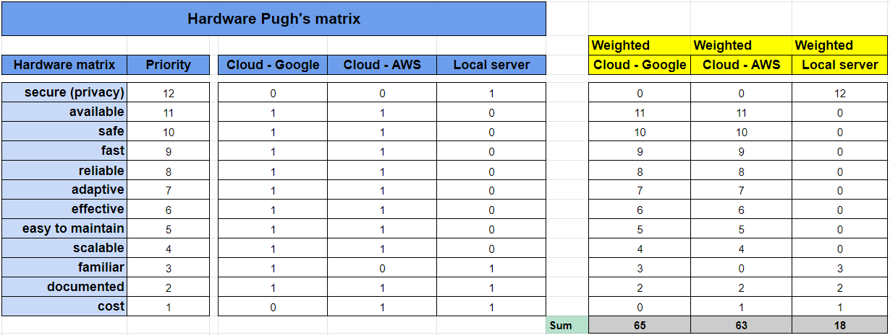

*Image 14. Pugh’s matrix for hardware approaches.*

It can be seen on this table that the best solution following the quality attributes selected is Google Cloud. AWS is also a great solution but will not be the chosen one for this project. Finally, the local server appears to be less adequate for our solution. These choices will further be analyzed in part 4.4 *Chosen approach*.

In image 15 the software matrix is illustrated. The alternatives standalone website, headless website and application were assessed with the help of twelve quality attributes, ranked by priority: usable, safe, educational, interactive, learnable, memorable, accessible, easy to develop, adaptive, fast, modern design, easy to maintain. A short description of these attributes can also be found in image 16.

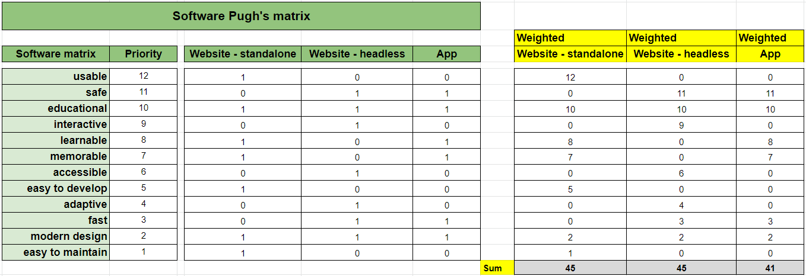

*Image 15. Pugh’s matrix for software approaches.*

By comparing the different solution approaches against each other a numerical result was generated that could be read as how beneficial the approach would be for the solution. The results from the Pugh’s matrix shows that from the chosen attributes the headless design and standalone website would be the suitable choice for the solution. A more in depth discussion of choice will be explained in *4.4 Chosen Approach.*

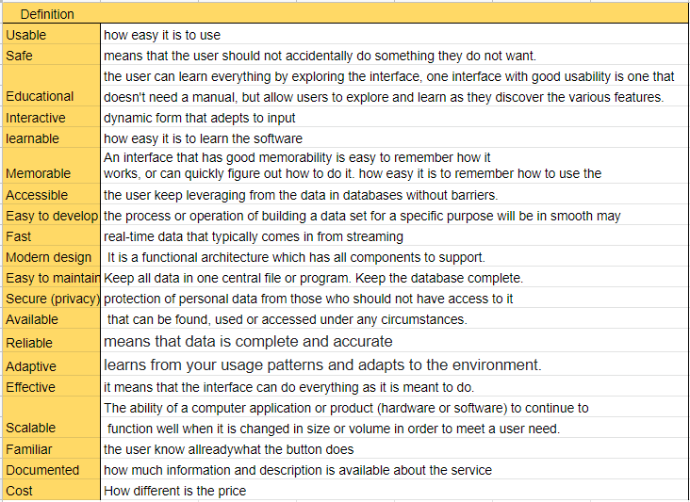

*Image 16. Definition of the words in the matrix for hardware and software approaches.*

## Chosen approach

Since privacy is a major requirement for the company considering data processing, the website will be hosted in GCP and process the data for Artificial Intelligence on a server hosted on the company’s servers.

Cloud hosting, being secure and easy to use, will also enable the group to discover and work on multiple platforms. Since the solution will be integrated to existing websites, using a cloud service is preferable because it’s more flexible. GCP and AWS provide sensibly the same characteristics and services. The reasoning for choosing GCP in this case is the familiarity some members of the group have with this one compared to AWS.

Local server is really great for quick prototyping and development but it’s usually not suitable for demonstrations, since it can only be accessed locally. Local servers will be used during development and then the website will be uploaded to a cloud service for demonstration purposes. The company’s servers could have been used for that, but it’s not as flexible as the cloud solution because of the security processes. Also, when the group will hand in the final code, the company will have the possibility to host our website as they please, the solution will not rely on the hosting hardware to work.

For the choice of software the group agreed that making an application will not give the desired result that Bolagsverket is looking for. An application would not allow for Bolagsverket requirements to be met. Bolagsverket specified the requirements for a solution that could be hosted on their own intranet. Bolagsverket also wants the solution to be widely available and quick to access. The group has decided to start with a standalone website for the first prototype. The reason for this is that a standalone website is easy to set up on a local server and it allows for quick prototyping. The goal is then to make a headless design and build upon the solution until it reaches the desired result. By making the solution a headless design it would mean that Bolagsverket then has the control to merge the solution into already existing services.

# Implementation

To get a technical overview of the whole solution, here is a schema containing every service in the project, and their communication see image 17.

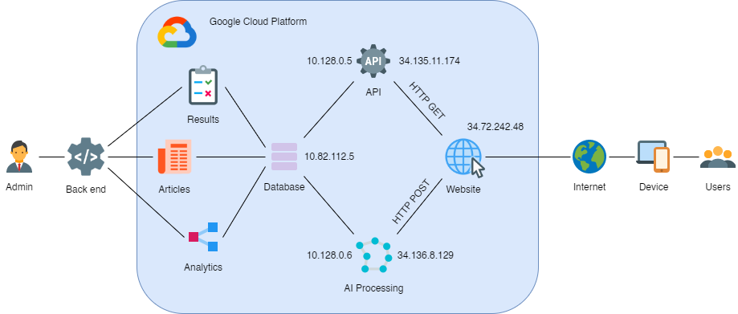

*Image 17 : global architecture of the deployed solution on the Cloud*

As you can see on this diagram, most of the services are hosted on Google Cloud and accessible to every user connected to the internet. The front end and the API communicate with HTTP requests (GET and POST). The front end and the AI service communicate with HTTP requests (POST). The backend is using a direct connection to the database for more flexibility on the actions possible. For more information about the code, refer to appendix A.

## Front end implementation

Before developing the front end, some mockups of the design were needed. These mockups are really important because with them, everyone can agree on the look and functionalities of the website. With mockups, it’s easy to refer to them to code with others on the same page.

The following information is regarding the sustainability barometers website. This is the front end with an user interface that the user will interact with while using this sustainability barometer service.

After discussion with bolagsverket early in the development process it was suggested that the solution should be implemented with headless design. By making the front end follow headless design architecture it gave the opportunity to choose between multiple programming languages and frameworks for developing the front end. It was decided to use the Javascript framework Vue for developing the front end for a couple of reasons. Vue is being used by developers at Bolagsverket. For the group's front end development it was an opportunity to learn this modern Javascript framework from developers at Bolagsverket with experience and to receive input on how a modern user interface is built.

It is most common to combine multiple libraries together with a framework for an easier development process. For stylizing the web page a library called Vuetify was chosen because of its well structured documentation. There was also a library called Vuex that was used in order to give the program code better structure.

Some general design choices for this web service was to have multiple pages that focus on its own specific task. There was going to be one header that was to be shown on every page containing the service name, and a “hamburger menu” for quick navigation between every page. See Image 18 for an illustration of the “hamburger menu”. 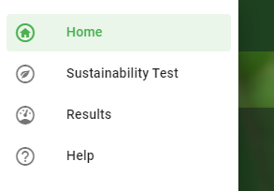

*Image 18. “hamburger menu” accessed from header*

Instead of a minimalistic approach to the web page it was decided to focus on having an informing web page. This decision was made in the group and also enforced based on feedback from user tests that a more informative website would be more suitable for an authority whose goal is to reach as large an audience as possible.

The pages that would make up the front end for the sustainability barometer is further explained below, and what the goal was for each page.

Landing Page

The landing page was the first element that the user would see when accessing the sustainability barometer. The landing page's purpose was to give a quick introduction to the service and how it works. Simple design was in mind while creating this page, to minimize the risk of a confusing first impression of the service. There are two buttons to redirect users to more information or towards the test.

Information Page

For the user to get a better understanding on what sustainability is and how the service works it was natural to have this information explained more in depth in its own page. This information was created to motivate and educate the user on sustainability.

Form Page

The form page is where the user was going to take the sustainability test and this would be one of the biggest components of the whole service. Most time was put on planning and creating the form page and the result page since these are the key parts of the front end. The form page's main content is the form that displays questions and provides answer options for the user to choose from. These questions are put into four categories, Economical, Social, Environmental and Influence. A description was added to each page to further explain the concept of sustainability in these specific areas. These descriptions are to put more weight on the questions and give an explanation to why these questions are asked in order to evaluate sustainability.

There were multiple different suggestions for how the questions were to be answered. There were three options that were thoroughly discussed. First option was to let the user answer each question with free text in a text box. This would require AI to analyze the answers in order to evaluate them for the result. This option was something that would be suitable for the service but it was not to be prioritized since the short time period for the project. The other option was to let the user answer the questions with a scale of one to nine. This was planned to be implemented for the solution but after discussion with Bolagsverket there was the feedback that multiple users might interpret numbers differently. And this led to the decision to use words as options for answers, and to use exactly four answer options in order to not have any middle value. This makes the user have to choose an answer that gives more value to the results. There were also some questions that only had the yes or no answers in order to show or hide other questions. see image 19 for and illustration on how the answers options are shown for every question.

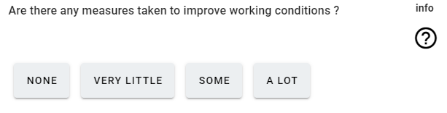

*Image 19. The four options for answering questions*

Since the questions in the form are not targeted towards a specific work area it was decided to add further explanation to some of the questions that are being asked. These explanations are not shown by default to free up some areas of the page. The extra help information for questions is quick to access by hovering the mouse over the question mark next to the question. This help text gives examples and were designed to help the user give a more accurate answer to the question see image 20.

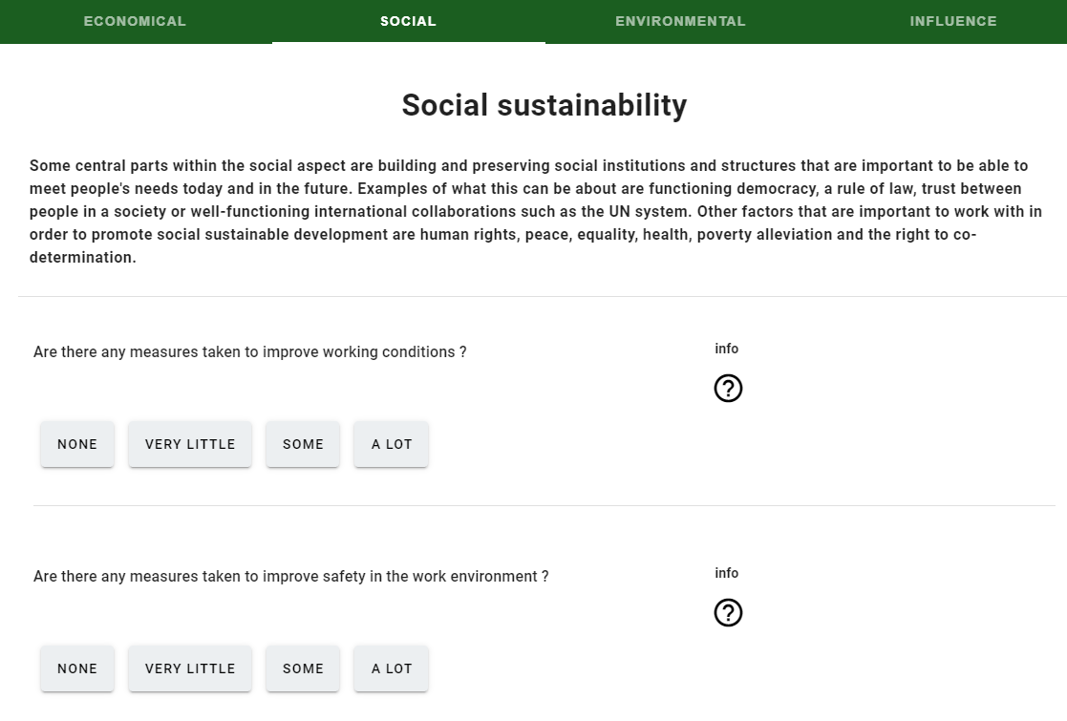

*Image 20. The form with questions*

There are also questions that show or hide other questions in the form in real time. This makes the form dynamic and the purpose of hiding some questions is to not show too many irrelevant questions to an entrepreneur depending on previous answers.

Each answer has its own value assigned to the answer option. If the user were to answer a question with the option “None”, then that question will receive a value of 1. If the user answers the question with the option “A lot” the question would be given a value of 4. This value for each answer option is set in the database and the purpose of this is to be able to combine the value of one question together with the value for that question's answers. In this way the answers could be weighted differently depending on the question. In the current state of the service there is no value for each separate question. There are only the values for answer options.

When the whole form is finished an average value will be calculated from all the questions in one tab. This new average value will now represent the result of this category. An average value is calculated for every category in order to be sent to the AI for evaluation see image 21, each index in the list represents the category score.

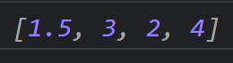

*Image 21. The result from taking the form*

Result Page

The result page is shown when the user has completed the form with questions. The result page has the purpose to show the result and to provide articles and links on how to improve the users business idea regarding sustainability. It was important to have the user understand the results. And to help with clarification the result is displayed both with the help of text and color.

The result from the form could be that the business is either sustainable or not sustainable. All categories were to be shown in order for the user to see which categories were satisfying or not according to the result. A category would be highlighted in green if the result was sustainable in that category, and highlighted in red if the result was not satisfying regarding sustainability. This would give the user an overview of the whole result and on what specific areas that the result was satisfying in or not see image 22 for an illustration of this description.

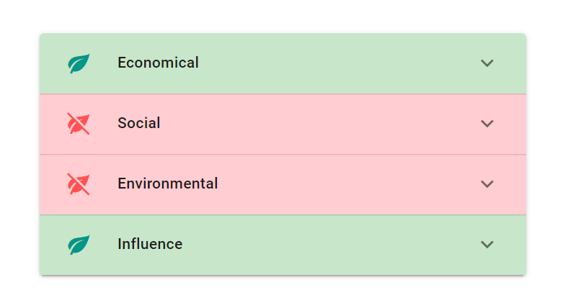

*Image 22. The category tabs from the result page*

In order for the user to see the articles on one of the categories the user would have to expand the category by clicking it see Image 23. Another approach that was discussed was to show all results for each category in one long page. This would then lead to the user having to scroll through every article in order to find the area where the result was not satisfying. With many articles this could lead to a lot of scrolling through articles and it increases the risk that the important articles might be missed. The decision was made to have expanding tabs that have the information in them to avoid mentioned problems. When the user clicks on the article the user will be redirected to the page where the article is. The articles are retrieved from trusted sources with the help of artificial intelligence. It was important for these articles to be from a trusted source since Bolagsverket is an authority.

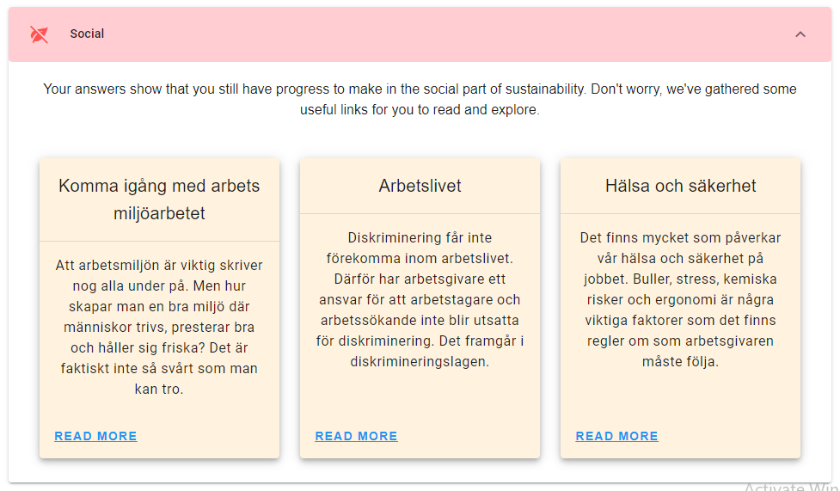

*Image 23. Articles from database*

The final functionality in the result page was to save the result. For keeping the service as available as possible it was decided to not handle any user login system. For making saving any results possible a unique code was going to be generated for every result. This code could then be saved by the user in order to access the results at a later time. If the user were to navigate to the result page before having taken the test, there was going to be an input field where the user could enter their code in order to see previous results. see Image 24 and Image 25.

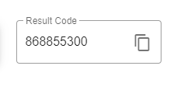

*Image 24. Generated result code*



*Image 25. Field for entering result code*

## Database implementation

In order to get a technical overview of the whole database solution, it is illustrated with a diagram of the database and the tables. All tables that are used in this diagram are divided into two parts; the diagram shows tables and their relation. see image 26.

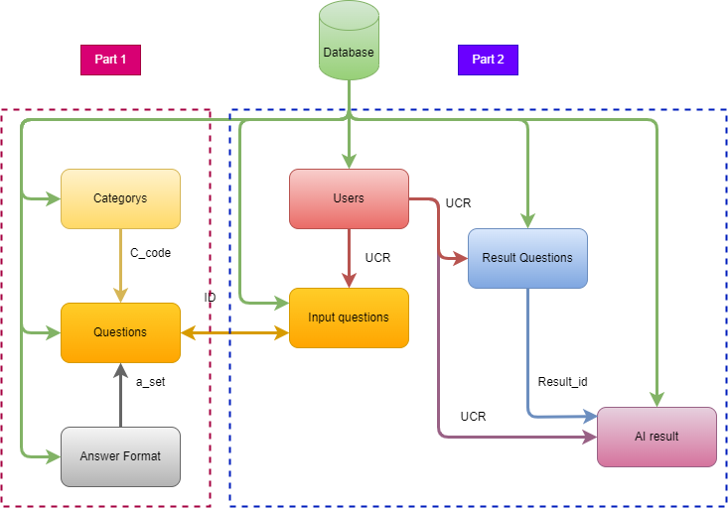

*Image 26. The database diagram*

When a client answers questions and gets results at the same time, all information that is related to a random registration code is saved. In that case database tables are divided to two parts:

Part 1: In this part, tables are used to display information in the front end and it can be flexible to update and maintain the website for different categories, questions, and answer formats instead of using hard code.

Part 2: Are used for saving information from the front end and AI processes it with related random user registration code that can be keys to join, retrieve, edit, import, and export information in the back end part.

The following diagram displays real database and tables with their relation. see image 27.

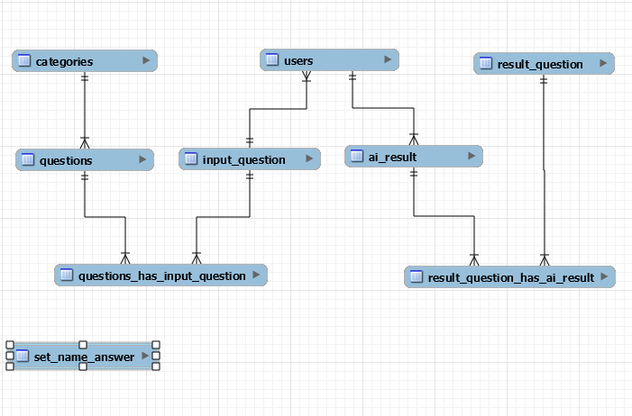

*Image 27. The database diagram*

## AI implementation

The module works by using the Naive Bayes statistical algorithm which is a classification technique based on Bayes' Theorem with an assumption of independence among predictors.

Where the module trains through advance results from different companies and this step call (train the module). When the module gets new values, this step call (test set).

Then, the module determines to which class the test values belong.

There are several algorithms that can be used in AI to determine the prediction, the choice of naive bayes algorithm is because it has a high value in the accuracy.

A cross-validation method has been used to determine the accuracy, where it takes about 20 percent of the data set as a test set and 80 percent as a training set and do the prediction passed on the training set.

The good thing with this method is that it can be done in iterative ways 5 or 10 times, and each time the module chooses a different test and training set than the previous time to make the prediction.

## API implementation

For the API, once the choice was made, the installation could begin. Laravel is a web framework that is easy to install and provides great examples to start with. The documentation is also great, so it was quite easy to write API calls. The format used for the data is JSON, a standard for API calls because it is easy to format complex data with it.

For this project, HTTP GET and POST requests were used for the API calls. For example, GET requests were made to retrieve questions from the database. POST requests were used to save results in the database for example. When too many API calls needed to be written, it was time to organize everything into controllers. A controller is a class that contains various methods related to a table in the database. So that way, every API call was organized according to the table they were linked to.

Finally, the API could be moved to Google Cloud so that everyone working on this project could access the data from the database. Since the API is made to operate behind the scenes, there is not so much to show, but here is for example the output of an API calls getting the questions for the form. see image 28.

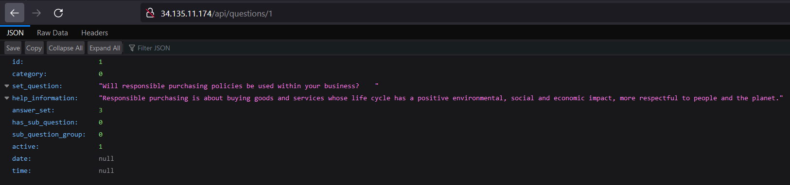

*Image 28. Output of an API call*

## Back end implementation

Back end project consists of five sub-programs that can be used in this solution. Main program is ’**Wproject22**’**.** see image 29.

## 

*Image 29. The project solution*

Here is the ’Main’ form that can be connected to the database and run other projects that are used. see image 30.

## 

*Image 30. The main control form*

As you can see it is the ’Main’ menu for running each part of software and the administrator has access to the database and tables. Each form has a different button to add new, edit, delete, search, refresh and cancel. see image 31.

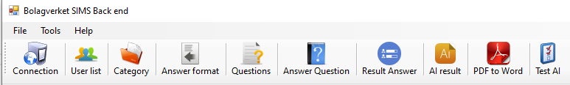

*Image 31. The main menu bar control form*

Some of those buttons are common in other forms depending on usage of it .For example for ‘Delete’, if it is needed to delete a user, it should be checked to remove it from all related tables based on relations in the database. see image 32.



*Image 32. Toolbar*

Main form has different parts, ’**Menu bar**’, ’**Tool Strip menu**’, ’**User information list**’, ’**AI result list**’ and ’**Result diagram**’. You can scroll down in the list of users and at the same time see the display diagram and AI result row related to the selected user. It is shown in the pictures below. see image 33.

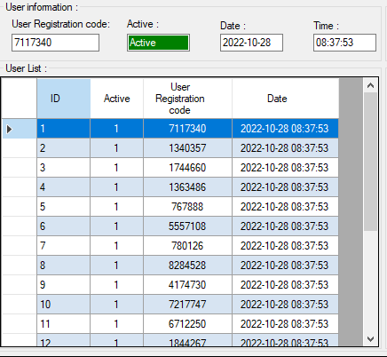

*Image 33. User Information*

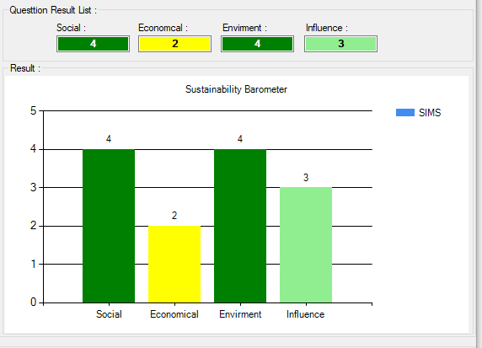

*Image 34. Result statistics*

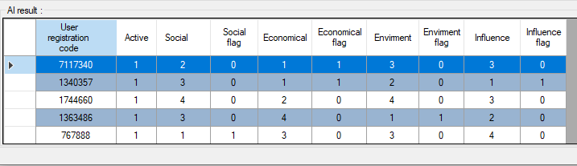

*Image 35. AI result*

In this part it is tried to explain the menu bar with information about each button that the administrator has access to.

Administrators can select connection to the database project tables. In that case it uses port 3306 to connect ’MYSQL’ server but in future there could be other options for port number to select from the list(e.g ’SQL Server’). see image 36.

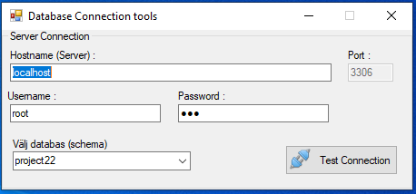

*Image 36. Database connection*

’User form’(below Image 37.) displays information about users who admin can:

1. Add manually new user :

When an admin wants to add a new user manually, the sub-function program checks the new user registration code and if the user doesn’t exist then gets permitted to add it otherwise it shows a message that the user already exists.

2. Edit :

By selecting a user (with its registration code) Admin would be restricted to inactivate it but in future depending on information related to the user he can change some other information except user registration code.

3. Search:

Admin has access to search in users table to find, check, etc.

4. Refresh table:

User tables would be refreshed in case new users are added and the list would be refreshed. In the future, setting a timer on the list of users (DB table) would be refreshed automatically to check and fetch new users. It is possible in the setting of tools to add a timer to select the period of time of refreshing (e.g. 30 minutes, 1 hour,…)bar admin can add timer to do that.

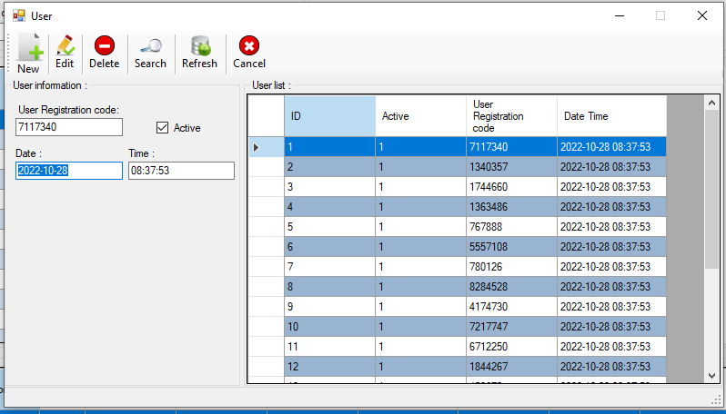

*Image 37. User table*

The admin form can use import, export information as ’XML’, ’JSON’, ’CSV’ files.

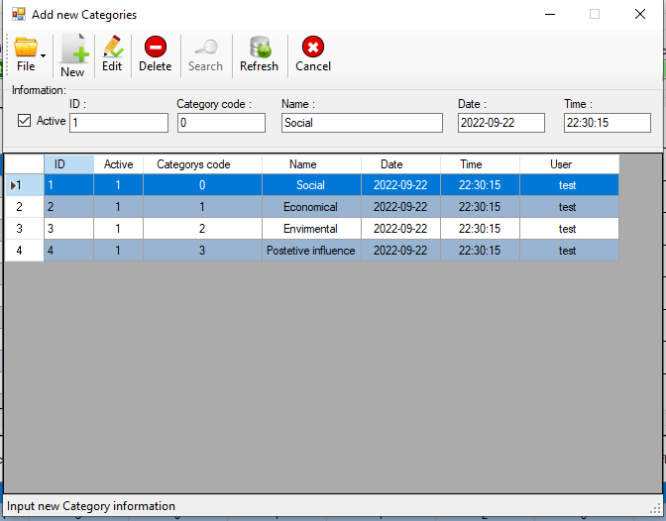

*Image 38. Categories table*

It uses some groups of answers in the database and based on the answer a group of answers would be shown in ‘Answer form’. For example group1 has only answers for ‘Yes’ and ‘No’ and group2 has answers: ’Yes’, ‘No’, ’Probably not’. Based on the question which is selected in form(in website) the related group would be shown in ‘Answer format’. see image 39.

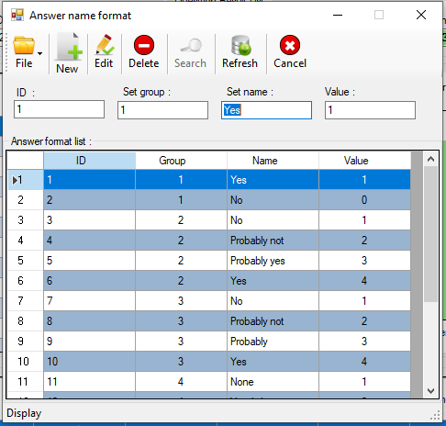

*Image 39. Answer sets table*

‘Question form’ displays information about questions and categories that are related to each question. In this form two tables are connected to this form.

Active column helps the user(admin) to inactivate by setting value to ‘0’ and activate questions by setting to ‘1’ in the website. see image 40.

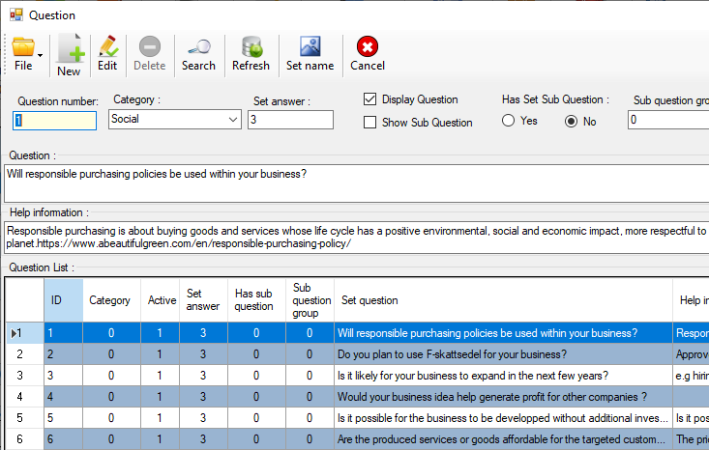

*Image 40. Questions table*

When the client answers to each question all answers would be saved in the ‘input_question’ table. In ‘Answer To Question’ form displays answers questions for each client. Admin can scroll down to see which answers have been saved for each client. see image 41.

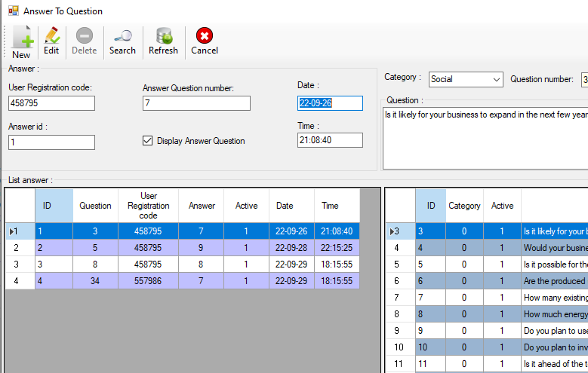

*Image 41. Question answers table*

Below image shows how admin can search for answers, user registration code, date, question text then show all answers that are related to the client. see image 42.

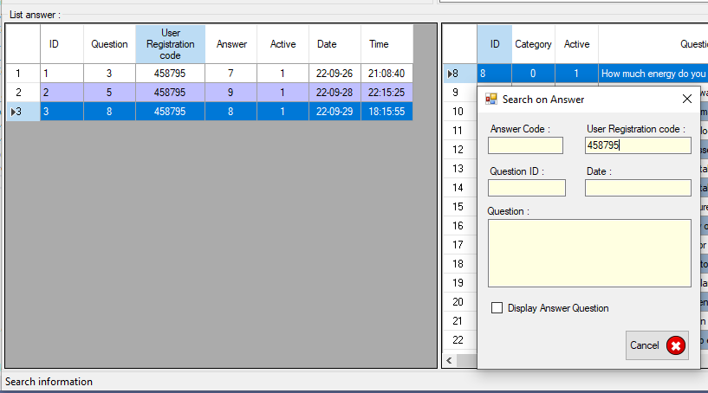

*Image 42. Search*

‘Result question and AI ’ looks like ‘Main form’ but here admin is permitted to do more like edit. see image 43.

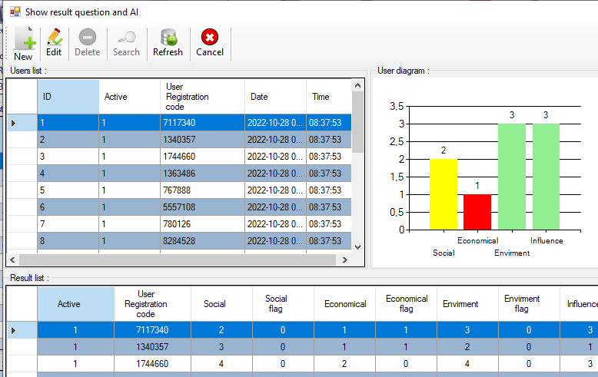

*Image 43. Question results*

‘AI report’ is a flexible part to show different reports about categories that can help Bolagverket to know more about how it can be developed and create more diagrams about other questions. It can also help other companies to start and develop. In future it might change and some other options could be added(depending on Bolagsverket needs). see image 44.

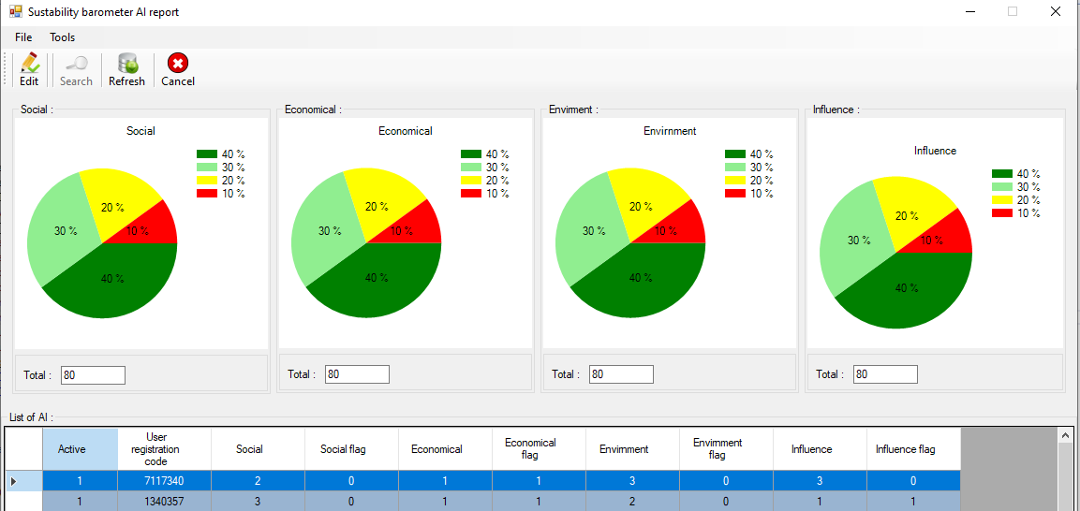

*Image 44. AI report*

This part of the software helps the admin to open pdf files. Reading and searching on Bolagsverket files that help to use pdf documents for getting more information. see image 45.

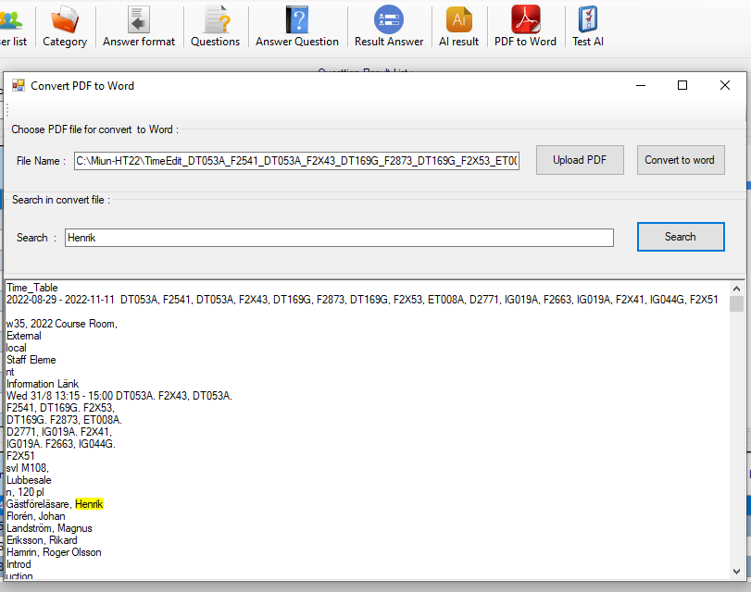

*Image 45. PDF reading tool*

This form is used by admin to create new random user registration code, answer questions and see AI results and then add information to tables. This form is a run throw utilities project. see image 46.

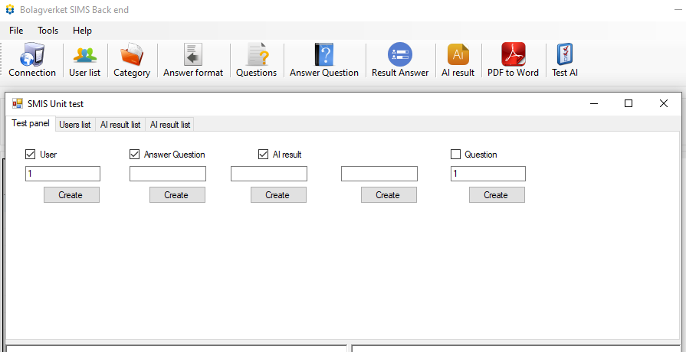

*Image 46. Unit test*

That is ‘About’ form to show about software.

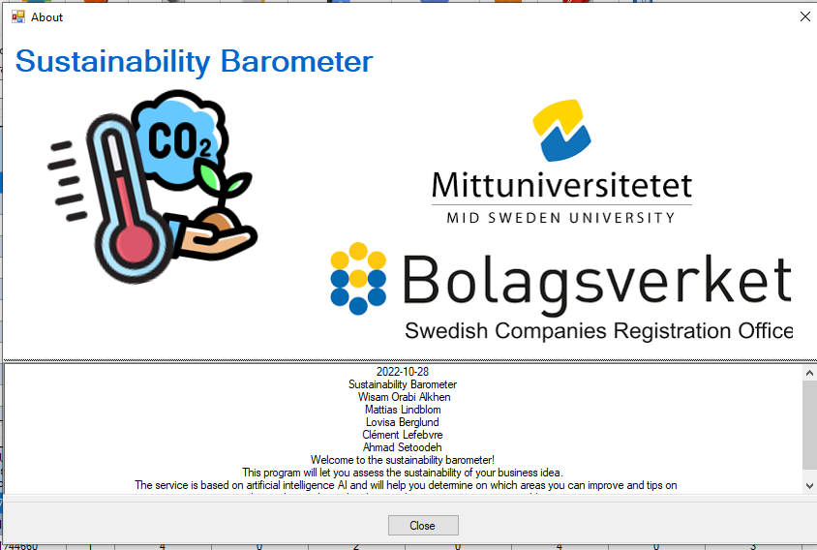

*Image 47. About page*

# Results

In this chapter, all the results that have been generated during this project are presented. First, the results that were generated during the first phase of the project are presented in chapter *6.1 Emphasize and define*. Then, the results of the second phase are presented in chapter *6.2 Ideate.* In chapter *6.3 Resulting system* the results of the prototyping phase are described. Finally in chapter *6.3 Measurement results/ test* the the results of the testing phase are presented.

## Emphasize and define

### NABC- pitch

The result of the NABC-pitch that was created and presented for the innovation coaches is compiled below. The pitch was presented orally in front of the innovation coaches in 1,5 minutes. For this reason the pitch was directed as a speech to the innovation coaches.

Need   
This year 7 million acres of forest were burned down due to fires. If we don't do anything right now or in the following years the world is doomed. This is one of the environmental problems right now. Since companies have a big impact on this, Bolagsverket takes this issue very seriously.

Approach   
We have developed a website using Artificial Intelligence to assess the sustainability of a business. The entrepreneur will be able to take a form containing specific questions, and then he will be presented with educational material (articles links) on ways to be more sustainable.

Benefit  
A big goal would be to implement the solution globally, by doing this it could help companies develop their businesses in a more sustainable way. For Bolagsverket this is something that could help to develop partnerships since most companies are aiming to be more sustainable. There are also funds to help companies make the green tranzition .

Competition  
Today there exist similar solutions on the market but these solutions do not help to improve sustainability nor does it use artificial intelligence. Our solution does!

### SWOT- analysis

Image 48 illustrates the result of the SWOT- analysis. The SWOT- analysis aimed to position the service on the market and thereby to analyze the team’s capability to reach the project goal. This with regards to internal and external impact.

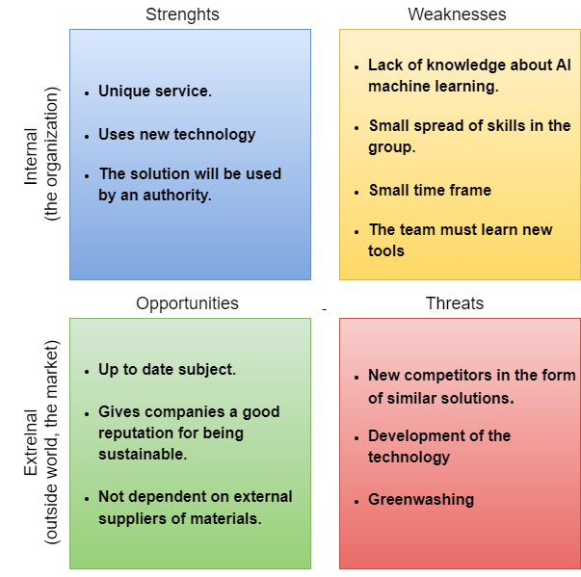

*Image 48. SWOT- analysis for project work regarding the sustainability barometer.*

The study of the internal category strength, concluded that the sustainability barometer is a unique service. The few similar services that exist do not seem to help the user to improve their sustainability work. They just evaluate your sustainability work. The sustainability barometer also uses new relevant technology to give the user relevant information. Keeping up with technological developments was expected to be an advantage since it reduces the risk of being out conquered by other services with technology that can generate more accurate solutions. Also the fact that the sustainability barometer will be used by an authority was considered as a strength. Everyone who is going to register a company will be exposed to the service. If the entrepreneur is recommended by Bolagseverket to use the service it is most likely that the entrepreneur will choose this service over anyone similar. This becuses as a customer you would assume that governments recommend the best solution.

The study of the internal category weaknesses, concluded that a challenge for the team to develop this service is that the team has not very much experience working with AI and machine learning. Since the solution is machine learning oriented, this is something that was expected to make the project time consuming. A lot of new tools were also expected for the team to learn. This was also considered as a problem since the time frame for the project was very small. Another weakness that was identified for the project was the small spread of skills in the group. Almost all team members belonged to the same field of expertise. This was considered as a weakness since it can cause group thinking. More areas of expertise can challenge solutions.

For the study of the external category opportunities, it was concluded that the subject that the service covers is a very up to date subject. There is a will to be more sustainable in society today. This is something that was expected to make entrepreneurs willing to use the service. Another motive for entrepreneurs to use the service is that it can give companies a good reputation if they can prove to others that they work sustainably. Another thing that was expected to work as an opportunity for the service is that it’s not dependent on external suppliers or materials. This makes the service robust for impacts from the outside world such as distribution problems caused by e.g war, laws and politics.

Threats that were identified for the service was that the sustainability trend might bring new competitors with even more developed solutions. Another threat is that the technology is fastly developing. New ways and approaches for creating services are constantly offered. The downside that was concluded due to this is that the technology used in the sustainability barometer may be outdated soon. The fact that some entrepreneurs might think that the service is too cumbersome and unnecessary and therefore not use it was also considered a threat. The goal of developing this service is to get companies to run their business in a sustainable way. A threat to this is companies who use greenwashing. In case of this, the sustainability barometer will only be used for promoting companies that are faking sustainability work.

### Use case

As explained before, use cases are short sentences made to identify the actions different actors will be able to do with the solution. To better visualize the dependencies and actions, a use case diagram was made. Here you can see we have one user (entrepreneur) and one admin. This is the revisioned version of the diagram that was done at the beginning of the project. It is closer to the finished project than the vision we had at the beginning . see image 49.

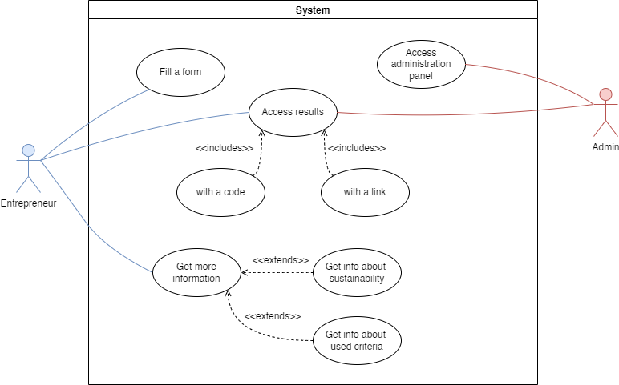

*Image 49. Use case diagram*

### Customer journey result

Image 50 illustrates the customer journey that was generated. The journey covers the intended activities the user will go through before, under and after they use the sustainability barometer. The action section represents what activities the customer does when using the sustainability barometer. For every action a touchpoint is also stated. The touch points represent what part of the service the customer interacts with for every action. What the customer is thinking and feeling when they are interacting with the service is also illustrated in the customer journey. The customer's feelings cause room for opportunities which is also stated.

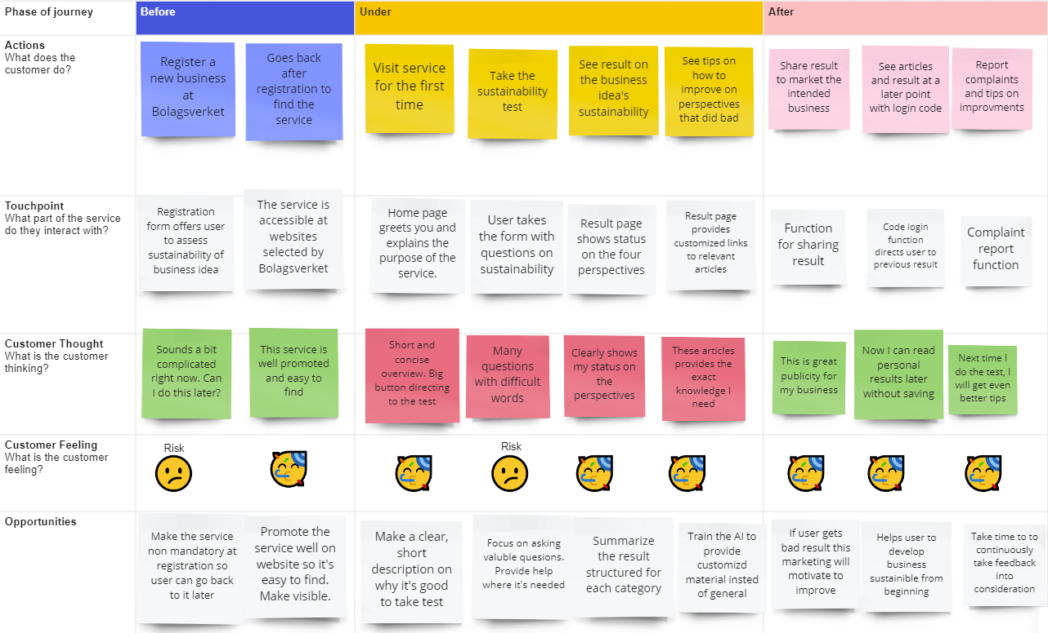

*Image 50*. Customer journey for using the sustainability barometer

### Impact mapping

The impact mapping that was done as a part of the requirement management is illustrated in image 51. The impact map covers what deliverables (the red rectangles) that are needed for stakeholders to impact the goal of the service.

### 

### 

*Image 51. Impact map for the sustainability barometer*

### Product backlog

Table 2 presents the list of requirements that was created as a result of the methodology described in 3.3.2 *Requirement management*. For every user story the actual requirement is also stated. Also what category the requirements belong to is stated in the table. The category represents how important the requirements were expected to be for the solution. Thereby the category also shows how important belonging features to the requirements were to implement. The intended user of the service is here called entrepreneur.

**Table 2:** Requirement list.

| **User story** | **Requirement** | **Category** |
| --- | --- | --- |
| As an entrepreneur, I want to fill a form containing sustainability questions so I can test my business idea. | Take a test | Must have |
| As an entrepreneur, I want to access a summary of my results after taking the test so I can get info about how I did. | Access result | Must have |
| As an entrepreneur, I want to get personalized sustainability info (e.g relevant links) depending on my result so I can improve my business idea. | Personalized sustainability information | Must have |
| As a developer, I want relevant questions so I can connect each question to the category that it belongs to (e.g social) in order to present relevant results and information from these. | Relevant sustainability questions | Must have |
| As an entrepreneur, I want information on how my data is used so I can feel safe about the information I’m sharing. | Information on data usage | Must have |
| As a developer, I want weighted questions so I can evaluate which questions contribute the most to the score given depending on which type of business is examined. | Weighted questions | Should have |
| As an entrepreneur, I want to access the form and results on any website where the service is implemented so I don't have to be redirected to another website. | Headless design | Should have |
| As an entrepreneur, I want an information page so I can get information about the service and how to use it . | Information page | Should have |
| As an entrepreneur, I want to be offered help to understand the sustainability questions so I can answer the questions reliably. | Help- button on the questions with explanation | Should have |
| As an entrepreneur, I want to access my results anytime so I can come back after taking the test and learn how I can improve. | Personal login code | Should have |
| As an administrator, I want a complaint report- function so I can get information about problems regarding the service. | Complaint report- function | Should have |
| As an administrator, I want access to every result so I can help with complaints and improve the service. | Access to every result | Should have |
| As an entrepreneur, I want to use the product in an expedient, efficient and user-satisfying manner so I can achieve specific goals. | High usability website | Should have |
| As an entrepreneur, I want to easily find information about the service so I don't have to spend time looking for info on the purpose of it. | Informative website | Should have |
| As an entrepreneur, I want to learn the interface by just exploring it so I can use the service in a fast and easy way. | Learnability | Should have |
| As an entrepreneur, I want the website to follow WCAG so I am able to use the website regardless of any kind of disability I might have. | Follow WCAG | Should have |
| As an entrepreneur, I want to be able to download a summary of my results so I can access these at any time. | Download result | Nice to have |
| As an entrepreneur, I want to get a certificate if my business idea is sustainable so I can ensure other future partners and stakeholders of this. | Sustainability certificate | Nice to have |
| As an entrepreneur, I want to be able to select another language on the website so I can understand the content even if I don't understand the language. | Select language | Nice to have |
| As another organization, I should be able to access paid and open data generated from the service in order to benefit my own business. | Access paid and open data generated from the service | Nice to have |

## Ideate

**6.2.1 Design studio mockups**

The result of the Design studio exercise which made up the first mockups for the website is displayed in image 52. Here the four different views are represented from each of the four participating teammember’s perspectives.

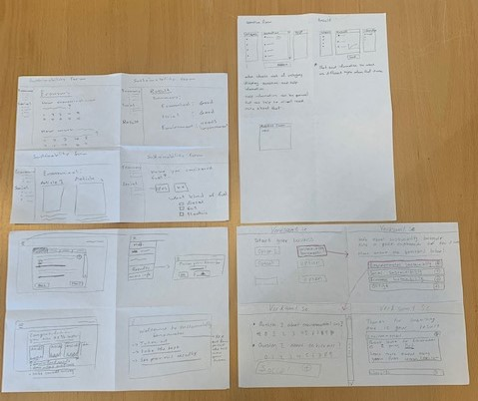

*Image 52. First mockups for the website.*

In image 53 the merged version of the result page, that the team created together from the individual sketches is displayed.

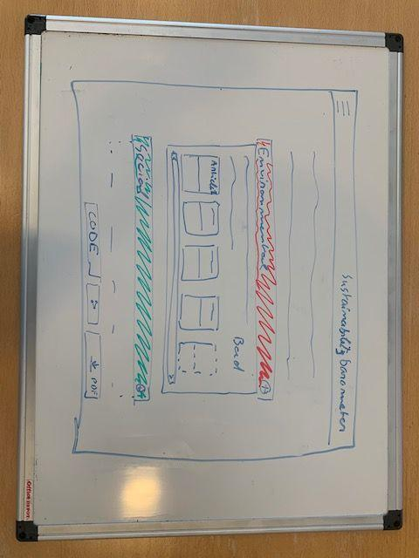

*Image 53. Merged version of Result page mockup*

## Resulting product

The final solution resulted in a website where entrepreneurs can assess the sustainability of their business idea. The service is based on artificial intelligence AI and will help entrepreneurs to determine which areas they can improve and tips on what to do in order to develop their business in a more sustainable way. To use the service called “the sustainability barometer”, the entrepreneur will fill a form with various questions about how he or she plans to run their business with respect to sustainability. The questions that are being asked are divided into the areas social-, economical-, ecological- sustainability and positive influence. The AI- model will then process the entrepreneur’s answers and assess whether or not their intended business is sustainable based on the four dimensions. If the business turns out to be less sustainable in a particular area, the AI- model will provide the entrepreneur with targeted and helpful tips on how to improve. This can for example be educational material such as articles or similar. In this way the entrepreneur will get immediate feedback on how sustainable their business idea is even before they start their business.

In image 54 is the result of the Landing page that was created for the sustainability barometer. The landing page serves the purpose to give the user a quick introduction to the service and how it works.

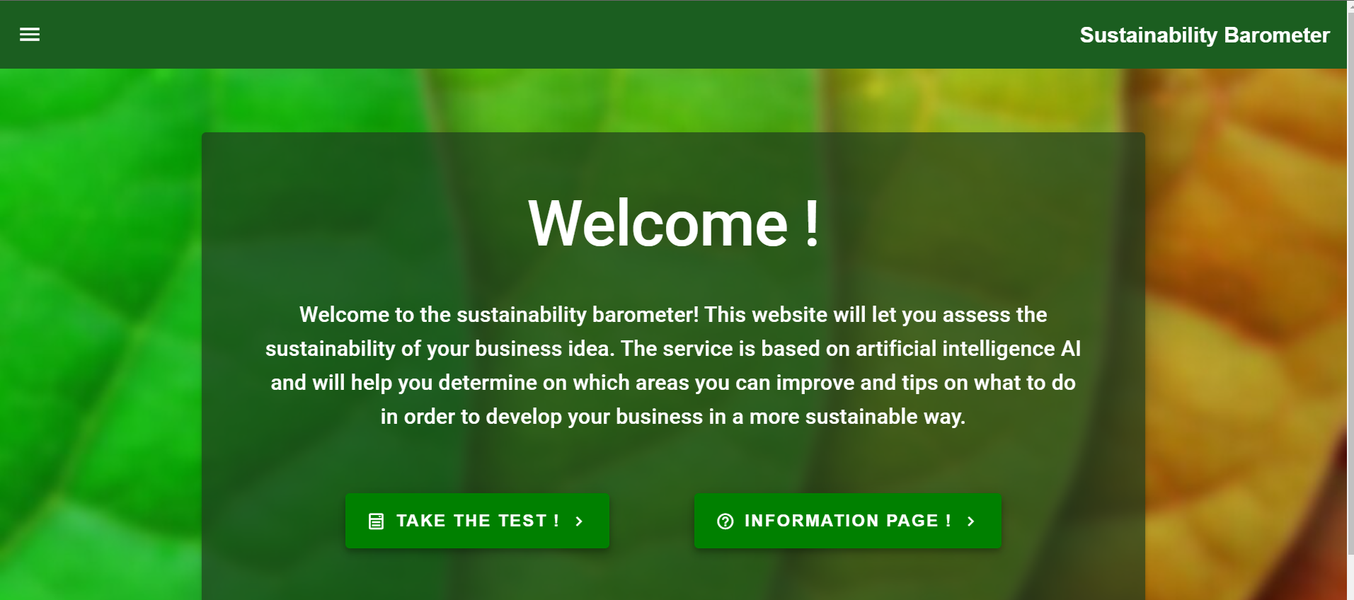

*Image 54. The landing page*

In image 55 is the result of the information page. This page is accessed directly from the landing page or from the “hamburger menu” that is available in the header of every page.

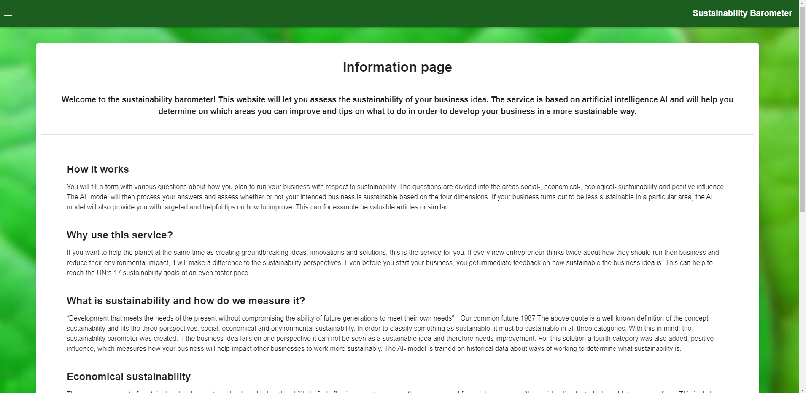

*Image 55. The information page*

In image 56 is the result of the form page. This page is accessed directly from the landing page or from the “hamburger menu” that is available in the header of every page. All questions in the form can be found in appendix x. It can be seen in the image that the questions are divided into the four different categories economical, social, economical and positive influence.

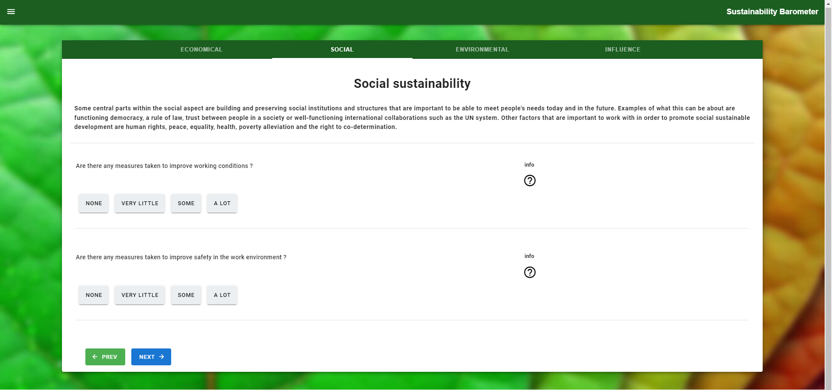

*Image 56. The form page*

In image 57 is the result of the form page. This page is reached automatically when the form is finished. The result page is also accessible from the “hamburger menu”. For this image the test has been taken in order to show some results that simulates a case of a real entrepreneur's expected results.

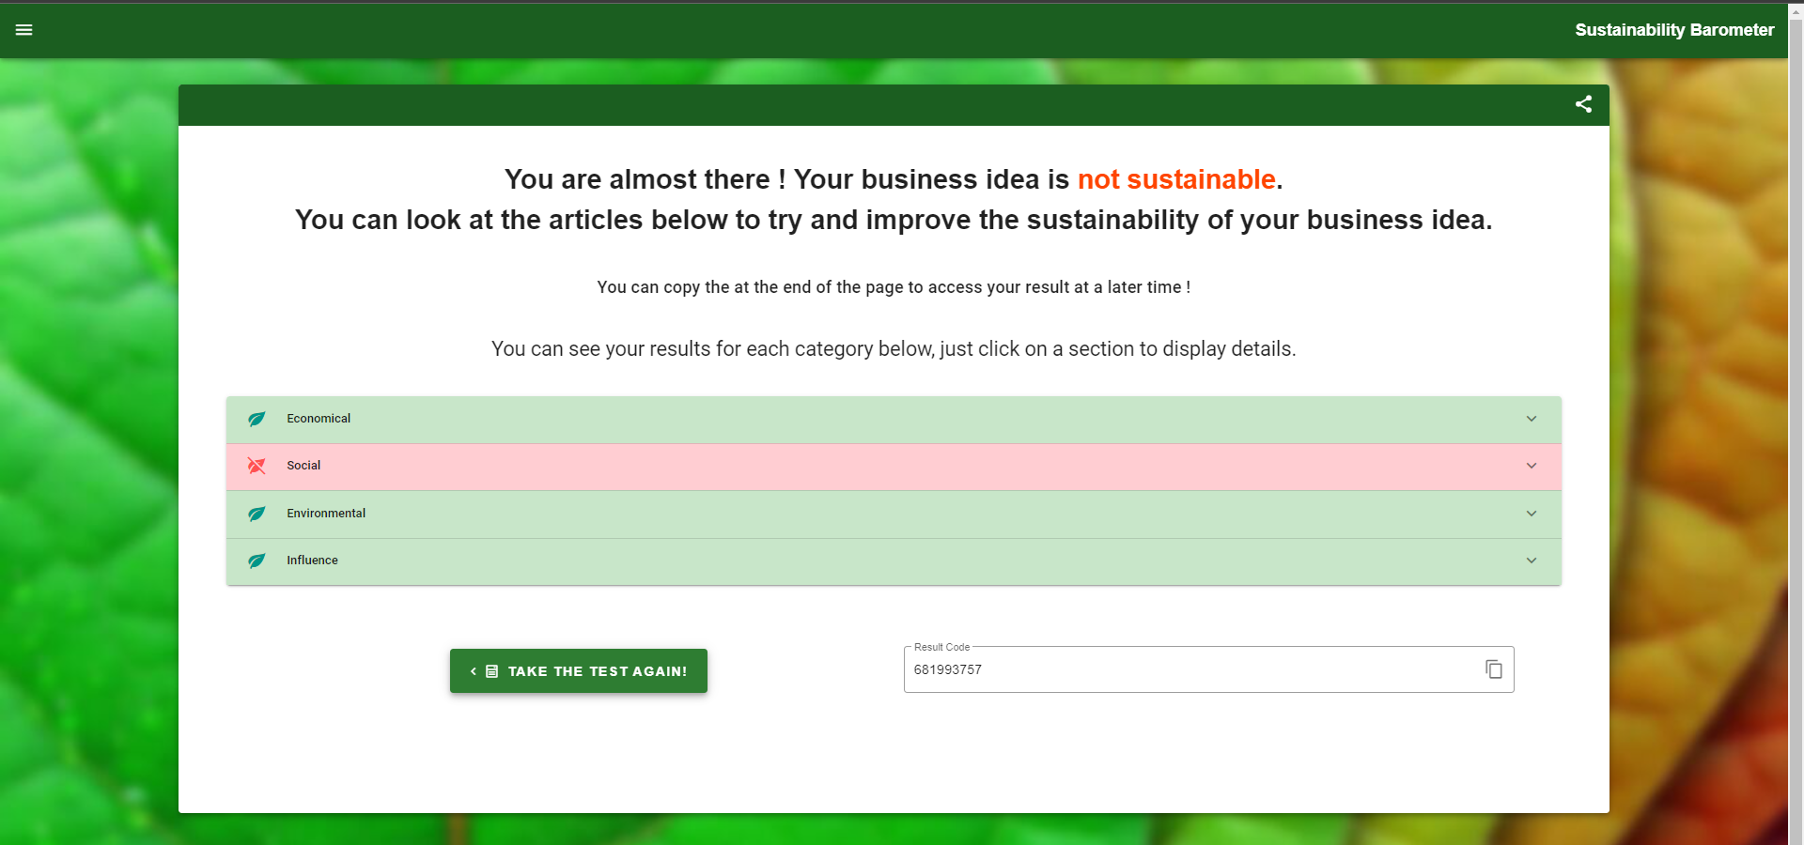

*Image 57. The result page*

In image 58 is the result of the form page when a category tab has been opened. There are articles in these tabs that the user can read and access through the links on how to improve regarding sustainability.

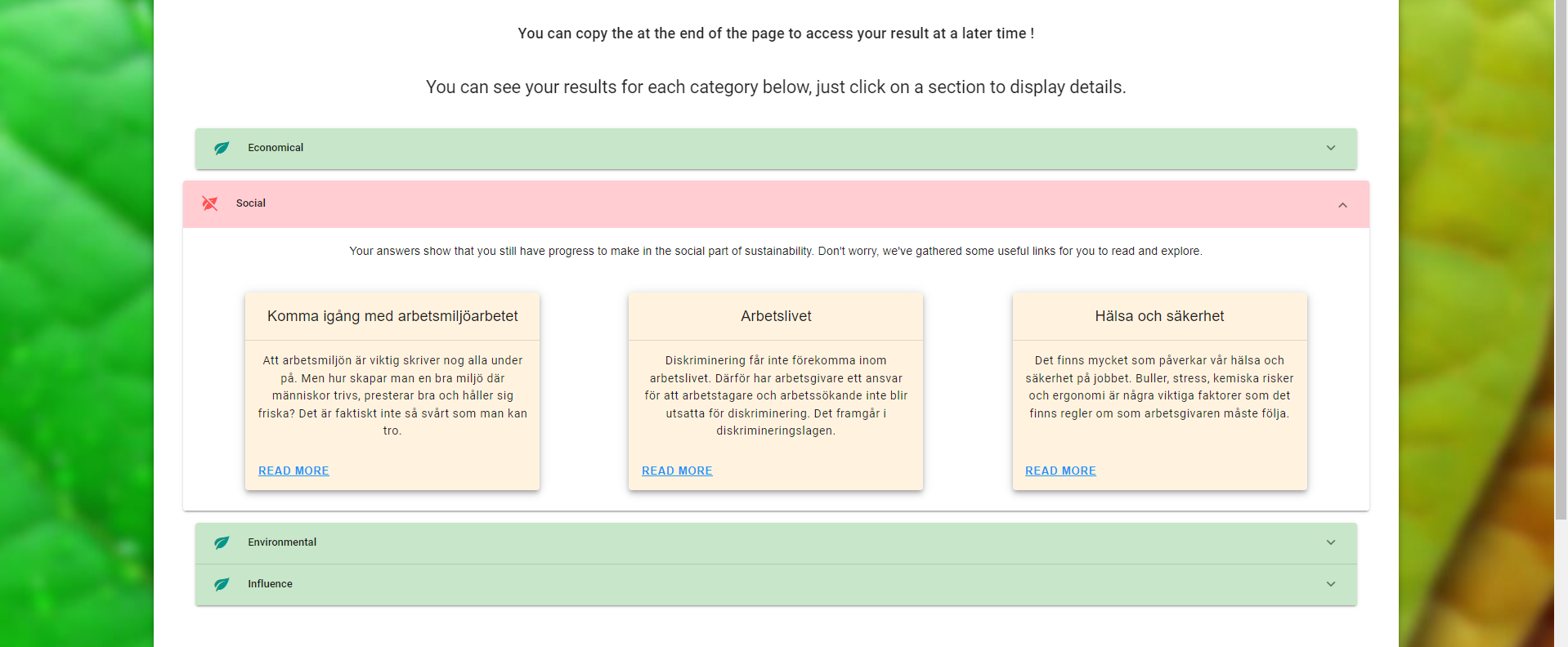

*Image 58. The result page inside a category tab*

In image 59 is the result page if the user did not previously take the test. Only accessible through the “hamburger menu”.

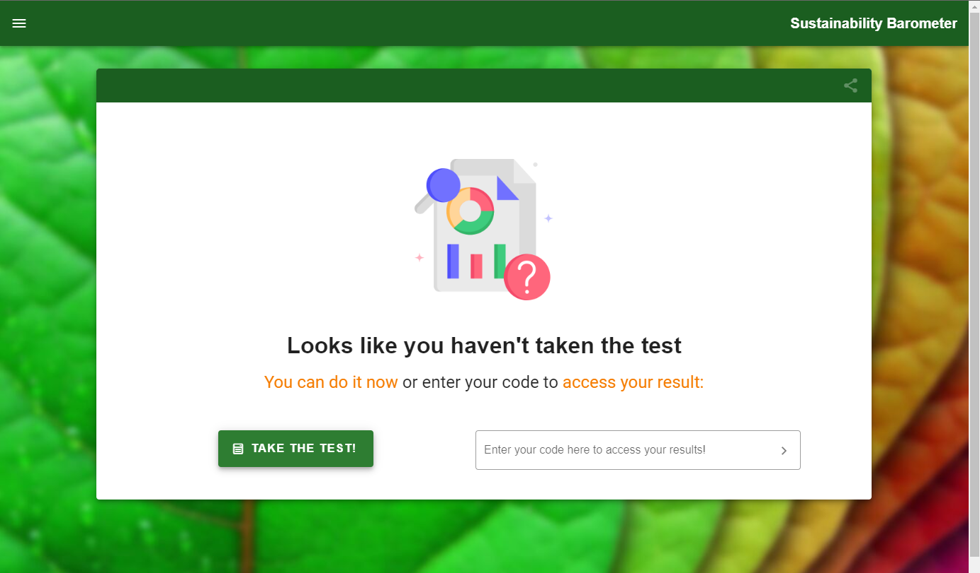

*Image 59. The result page if the test was not taken*

When the AI module gets the 4 different values ​​from 4 different categories, it processes these values ​​in an artificial intelligence way by using (Naive Bayes algorithm ) to determine whether these values ​​are sustainable or not and show the result. see image 60.



*Image 60. AI summarized result*

In addition, it brings relevant web links to these values ​​and shows them to the user. see image 61.



*Image 61. AI generated links*

## Tests results

This sub chapter presents the results from all the tests that were made.

## **Performance test**

The results obtained from the performance test of the solution is illustrated in image 62. The results were taken into account when correcting the last bugs to improve performance. Throughout the results, the type of computer did not matter in the performance, which is a requirement for a good user experience.

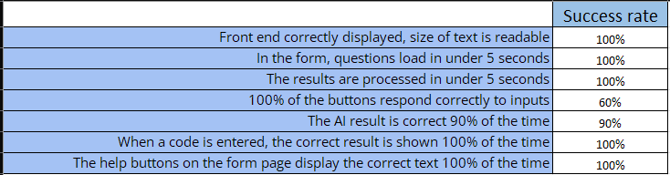

*Image 62 : success rate of the performance tests*

## User tests

The test results from the user test are displayed in the bar chart presented in image 63. The X axis represents the tasks asked to the user from 1 to 10, which can be found in the method sub chapter *3.3.5 User tests*. The Y axis represents the result of units used in each test (seconds, minutes, number of clicks).

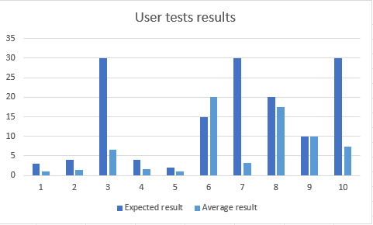

*Image 63 : bar chart presenting user tests results*

## Cross validation

The result from the cross-validation method gave the mean accuracy 96%. This can be seen in image 64.



*Image 64. Cross validation result*

# Discussion

In this chapter, the results of the different tests and methods are discussed. A small discussion about the project’s ethical and societal impacts is also presented at the end of this chapter.

## Analysis and discussion of results

## User tests discussion

What is interesting regarding the result of the user tests which is demonstrated in chapter *6.4.2 User test*  is not the actual unit but more the relation between expected result and the average of all the results.

As we can see on the graph, most actual results performed as expected (below the max expected value). For task 6 and 9, which are above and on par with the expected value, the difference can be explained by the difficulty of these tasks. Task 6 was “On the results page find two ways to access your result later” and 9 was “Try to access your result from a blank page with the URL.”. The titles of the task were not really clear, and due to some technical limitations, some functionalities could not be fully tested at the time of testing. It is also noticeable that some expected results values are way higher than the average of the actual values. This is a symbol of a great user interface that made navigation easy for the users.

## Project method discussion

In general, the scrum and design thinking method approach were executed properly and served as a structure throughout the project. They proved useful to organize tasks properly.

In another hand, the test method chosen was not adapted to this project. Test-Driven Development (TDD) was used during the first sprint, when each member of the group could work on their part.

TDD was dropped in the second sprint and onward because it was extremely time consuming. Also, since most technologies were new, it was difficult to prepare the tests in advance. A more traditional method of coding and then testing was used for the rest of the project.

For the tests (user tests and performance tests), both quantitative and qualitative requirements were used. The quantitative data could be processed and analyzed to improve some parts of the program. The qualitative questions were useful to get the general feeling of users about the website.

The dataset was created with (fake) data, but our goal was to create it with real and relevant data. The result of accuracy was high, this is probably because of overfitting since a faked dataset was used. The use of real dataset would probably have a more realistic accuracy.

## Consequence analysis

This project, while not impacting for now, may have great implications for the future. If Bolagsverket decides to pursue development, it could improve the sustainability of a lot of companies. For now, the target audience is entrepreneurs that don’t have a company yet, but it could be expanded to all companies in Sweden, even companies around the world. All the data collected could also serve to build a global knowledge of good practices to follow.

For the future, it was imagined that this sustainability barometer could give certificates of sustainability to companies respecting economical, social and environmental sustainability. That way, these companies could make an example for others and benefit from special funds for sustainable development.

## Ethical and societal discussion

The main problem that was given to the group was to find a way to improve social, environmental, and economical sustainability. In a way, the whole project is part of a more global societal improvement.

Efforts were made to make this website as accessible as possible for everyone, for example implementing guidelines for accessibility (WCAG).

Privacy concerns were taken into account all along the project’s development, and it was decided not to use any kind of personal information. Instead of using a login system, the information can be accessed with a uniquely generated code. Also, while Google Cloud was used in this project, it was only for testing purposes, as the entire solution can be hosted anywhere.

To prevent any malicious use of the website, we tried to secure it as much as possible, but the interest of gaining unauthorized access is limited because of the public nature of information processed and stored. In the future, if certifications were to be given, the form should have a way to identify companies trying to greenwash their business.

# Conclusions

In the end, the group was able to deliver a fully working website to Bolagsverket, which was satisfied with the result.

The problem that structured the whole project was : How to help new entrepreneurs to develop their upcoming business in a sustainable way?

The sustainability barometer developed by the group is there to answer this question while providing a pleasant user experience.

The main goal fixed at the beginning of the project was achieved. Although every feature could not be implemented, the group is satisfied with the work produced considering the time allocated.

## Future Work

Because the project is not ready for production, in other words, because it is not ready for users, the first thing would be to make it ready for deployment on a large scale.

### Integration to other websites

To reach that large scale and because the whole project was structured around a headless architecture, it could be great to integrate it on websites relevant for entrepreneurs and companies. Integrating it to bolagsverket’s website or verksampt.se would be optimal.

### Optimization of the results

Few ideas were explored during the development process, to improve the quality of the results.

First of all, adding weights to questions based on the business field could greatly improve user experience, as it would show only relevant questions for the business. For example, a phone manufacturer would not be asked questions about animal abuse because of the field he is in.

Another way to improve the results would be to use real user data to train the AI model. Due to time constraints, made up data was used and as such, does not correspond to reality.

Finally, adding a ratings and complaints system could help get more relevant information to the users, especially for articles.

### Engaging users to take the test

To make users take the sustainability test, the idea of rewarding users was explored. It could be some kind of certification, or a way to differentiate companies that make efforts to be more sustainable. This could lead to a global system of distributing funds based on the sustainability of a company. Of course the solution would have to be able to detect greenwashing or the action of trying to convince the company is sustainable whereas it is not.

### Creating a global knowledge of sustainability

Because sustainability is a trending topic and because actions need to be taken to counter global warming, the data collected by this solution could be shared between every company, to help everyone be more sustainable.

# 

# References

[1] apachepersonal.miun.se “*Teaser: Bolagsverket SIMS project 2022 Create a Proof of Concept for a Sustainability Barometer!*” <https://apachepersonal.miun.se/~mageri/kurser/sims/case_h22/02_Bolagsverket_teaser.pdf>

[2] sdgs.un.org ”*Do you know all the 17 SGD’s*”

<https://sdgs.un.org/goals>

Retrieved:2022-10-29

[3] Sweden.se “*Swedish companies lead by example, making sustainability and human rights matter*” <https://sweden.se/work-business/business-in-sweden/sustainable-business>

Retrieved:2022-10-01

[4] H. Sharp, J. Preece, och Y. Rogers, Interaction Design: Beyond Human-Computer Interaction. 2019

[5] Thomas Gustavsson. (2020). *Agil projektledning.* (4th edition). Publisher: Sanoma utbildning [book]

[6] CIO. (2021). *What is design thinking? An agile method for innovation.* Retrieved: 2022-09-12

<https://www.cio.com/article/196199/what-is-design-thinking-an-agile-method-for-innovation.html>

[7] Interaction design foundation. (2022). *The 5 Stages in the Design Thinking Process.* Retrieved:2022-09-12

<https://www.interaction-design.org/literature/article/5-stages-in-the-design-thinking-process>

[8] ReashearshGate (2019). *Figure 2.* Retrieved: 2022-09-12

<https://www.researchgate.net/figure/Phases-of-the-Design-Thinking-process-with-emphasis-on-the-beginning-Source-David_fig16_335391703>

[9] innovation.lu.se “NABC - how to test your idea” <https://www.innovation.lu.se/en/our-services/developing-ideas-innovations/nabc-how-test-your-idea>

Retrieved: 2022-10-01

[10] Salesforce “*Så gör du en nulägesanalys (SWOT) för ditt företag* ”

<https://www.salesforce.com/se/blog/2021/08/sa-goer-du-en-swot-analys-foer-ditt-smafoeretag.html>

Retrieved:2022-10-02

[11] Design- process och metod Å. Wikberg Nilsson, Å. Ericsson, P. Törlind. 2016 Studentlitteratur

[12] Productplan.com “*Impact Mapping*” <https://www.productplan.com/glossary/impact-mapping/>

Retrieved 2022-10-30

[13] Happiness.se “*Vad är en user story?*” <https://www.happiness.se/artiklar/vad-ar-en-user-story>

Retrieved: 2022-10-04

[14] ProductPlan. (2022). *What is the Kano Model?* [What is the Kano Model? | Definition and Overview of Kano (productplan.com)](https://www.productplan.com/glossary/kano-model/).

Retrieved: 2022-09-12

[15] ProductPlan. (2022) “*Kano model*” <https://www.productplan.com/glossary/kano-model/>

Retrieved: 2022-09-12

[16] Ullman, David G. (1997). *The Mechanical Design Process*. McGraw-Hill. pp. 105–108. [ISBN](https://en.wikipedia.org/wiki/ISBN_(identifier)) [978-0-07-065756-4](https://en.wikipedia.org/wiki/Special:BookSources/978-0-07-065756-4). [book].----------

[17] Sam Newman, Monolith to Microservices: Evolutionary Patterns to Transform Your Monolith ISBN 978-1-492-04784-1 [book]

[18] Thomas, Bertil. Framtidens intelligens, Lund : Studentlitteratur, 2003, ISBN 9144030584.

[19] Scikit-learn ”*naive bayes*”

<https://scikit-learn.org/stable/modules/naive_bayes.html>,

Retrieved 2022-10-20.

[20] Storyblok.com *“Headless CMS explained in 5 minutes*”

<https://www.storyblok.com/tp/headless-cms-explained>

Retrieved: 2022-10-18

[21] w3schools.com “*What is Vue.js*”

<https://www.w3schools.com/whatis/whatis_vue.asp>

Retrieved: 2022-10-18

[22] Sustainabilityadvantage.com. “Basic sustainability tool” [Basic Sustainability Assessment Tool (BSAT) | Sustainability Advantage](https://sustainabilityadvantage.com/assessments/bsat/)

Retrieved: 2022-10-31

[23] Sustainableni.org. “Sustainability Assessment Tool” [Sustainabilty Assessment Toolkit - Guidebook part-revised 2016.pdf (sustainableni.org)](https://www.sustainableni.org/sites/default/files/Sustainabilty%20Assessment%20Toolkit%20-%20Guidebook%20part-revised%202016.pdf)

Retrieved: 2022-10-31

[24] Z. Martina, B. Rupert J. “Sustainability Assessment and Reporting of Companies” [Sustainability Assessment and Reporting of Companies | SpringerLink](https://link.springer.com/referenceworkentry/10.1007/978-3-319-95726-5_15)

Retrieved: 2022-10-31

[25] Owasp.org “*Top 10 Web Application Security Risks*”

<https://owasp.org/www-project-top-ten/>

Retrieved: 2022-10-19—-----

[26] Google. “Cloud storage ”,

<https://cloud.google.com/storage>

Retrieved: 2022-09-19

[27] Amazon, “Shared Responsibility model”,

<https://aws.amazon.com/compliance/shared-responsibility-model/?nc1=h_ls>

Retrieved: 2022-09-19

[28] D. Catherine, Algio.com, “*What is a headless website?”,*

[What is a headless website? | Algolia Blog](https://www.algolia.com/blog/ux/what-is-a-headless-website-a-definition-and-examples/)

Published 2020-08-10. Retrieved 2020-09-20

[29] codementor.io, “*How to write meaningful quality attributes for software development”,* <https://www.codementor.io/@antoniopfesilva/how-to-write-meaningful-quality-attributes-for-software-development-ez8y90wyo>

Published 2017-12-27. Retrieved 2022-09-19

# Appendix A: Source Code and website URL

During this whole project, we used github as a repository. Everything can be found at this address :

<https://github.com/ClemLef/SIMS-bolagsverket>

To get a demonstration of the hosted working website, here is the address at which it is accessible :

<http://34.72.242.48:8080/#/>

Please note that it will certainly not stay live for long, due to the expiration of the Google Cloud free trial. Also note that not all features are functional because of security reasons.

# Appendix B: questions for sustainability

| Category | Question |
| --- | --- |
|
| Economical | Will responsible purchasing policies be used within your business? |
| Economical | Do you plan to use F-tax for your business? |
| Economical | Is it likely for your business to expand in the next few years? |
| Economical | Would your business idea help generate profit for other companies ? |
| Economical | Is it possible for the business to be developed without additional investments and infrastructure ? |
| Economical | Are the produced services or goods affordable for the targeted customer ? |
| Economical | How many existing competing market solutions would you estimate exist ? |
| Economical | How much energy do you estimate your business will use ? |
| Economical | Do you plan to use green energy for most of the energy consumption ? |
| Economical | How much do you plan to invest to make your business more green ? |
| Economical | Is it ahead of the technology compared to existing market solutions? |
| Economical | By changing your processes to be more ecological, would your company still be able to satisfy customer needs? |
| Social | Are there any measures taken to improve working conditions ? Work from home, schedule, workload... |
| Social | Are there any measures taken to improve safety in the work environment ? |
| Social | Have you considered giving the opportunity to employees to unionize? |
| Social | Are there planned measures to prevent risks of child labour or social damage? |
| Social | Are there any risks today or in the future of an unhealthy work environment ? |
| Social | Is there a plan to allow for employees to have an health care hour (friskvård) |
| Social | Does the company plan to pay travel expenses to the employees? |
| Social | To what extent do you plan to include the employees in the company's decision making? |
| Social | Is the working environment suitable for people with disabilities? |
| Social | Do you have a strategy in order to support employment of staff with diverging ages, gender and religious views? |
| Social | Do you have a strategy to ensure equal pay regardless of gender? |
| Social | Do you plan to hire people from diverging age groups ? |
| Social | Is there any plan to allow for internships and apprentices? |
| Social | Are there any collective agreements for employees ? Ex. collective agreements for the truck drivers? |
| Environmental | Is the process going to use extracted materials (metal, coal, oil)? |
| Environmental | Are fossil fuels planned to be used in some parts of the business process ? |
| Environmental | Are carbon dioxide emissions going to occur in some parts of the business process ? |
| Environmental | Will your business be able to switch to a more green energy source in the near future ? Ex electric trucks in the next 10 years |
| Environmental | Does your business idea involve direct or indirect animal use? |
| Environmental | Are there any measures taken against animal exploitation? |
| Environmental | Will there be animal products in your transformed goods ? Ex : animal fat in candies |
| Environmental | Do you plan to propose alternatives for meat-based products (vegan...) |
| Environmental | Do your business ideas plan to support locally sourced products or services? |
| Environmental | Are there releases of persistent or bioaccumulating chemicals in use or production of products ? |
| Environmental | Does your business idea involve physical degradation of nature ? Ex : Taking down trees |
| Environmental | Is your business idea about producing goods ? |
| Environmental | Does the process or product contain any toxic chemicals? Ex : including suppliers |
| Environmental | Is the product designed with repairability in mind ? |
| Environmental | Is the process going to use the Reduce, Reuse, Recycle method ? |
| Environmental | Are there any dangerous residual products during the end-of-life cycle? |
| Environmental | How much byproduct is expected to remain from the production line ? |
| Environmental | How much of the waste product is going to be reused during the product life cycle ? |
| Environmental | Will the company take responsibility for the product life cycle? |
| Positive influence | Do you plan to cooperate with other entrepreneurs or companies with assignments regarding sustainability? |
| Positive influence | Do you plan to be a member in a union who work in order to promote sustainability work? |
| Positive influence | Do you plan to share information on how you work with sustainability to other companies? |
| Positive influence | Do you plan to improve your way of working to be more sustainable in economic systems? |
| Positive influence | Do you plan to improve your way of working to be more sustainable in social systems? |
| Positive influence | Do you plan to improve your way of working to be more sustainable in environmental systems? |
| Business | What is your business goal? |
|  | How do you plan to achieve your goal |
|  | Will your business be about producing services or goods? |

## 